

**2023**

|  |  |  |
| --- | --- | --- |
| Supervisor | Sir Mansoor Ahmed | |
| Batch | **PR2-202210B** | |
| Group | **D** | |
| Serial No. | **Enrollment Number** | **Student’s Name** |
| 1. | Student1427029 | Jaffer Junaidi |
| 2. | Student1421672 | Salman Yousuf |
| 3. | Student1414515 | Bilal Saqib |
| 4. | Student1426324 | Muhammad Shafay Hasnain |

# **Table of Content**

­­

* **Table of Contents**.……………………………….…….……………..**.01**
* **Certificate of Completion**……….………………………….….……....**02**
* **Acknowledgement**………………………………………….……...….**03**
* **Problem Statement**….………………………………...……....…..…..**04**
* **Functional Specification**.……………………………………...…….…**04**
* **Hardware and Software Requirement**…………..……….…….….……..**05**

* **Project Synopsis**…………..…………………………..…….….……..**06**
* **Website Features** …………..…………………………..…….…..…...**06**
* **Database Design**………….....……………………….......…….…..…..**07**
* **User Guide**………….....……………………....………….….…..…..**08-19**
* **Developers Guide**………….....……………………....…………….…..…..**20-24**
* **Developers Guide (Admin Panel)** ....……………………....……….…..…..**25-27**
* **Developers Guide (Customer Panel)** ..……………………....……….…..…..**28-30**
* **Developers Guide (Lawyer Panel)** …………......……..……….….…..…..**31-32**

# **Certificate of Completion**

This is to certify that  **Jaffer Junaidi, Bilal Saqib, Salman Yousuf, Muhammad Shafay Hasnain** have successfully completed their ACCP Prime 2.0

Semester II E-Project.

Submitted to: **Aptech Computer Education**

On

**September 29th, 2023**

# **Acknowledgement**

First of all we would like to thank **Almighty Allah** for giving us strength and ability to complete this project.

And then, we would like to express my special thanks of gratitude to our teacher **Sir Mansoor Ahmed** who guided us on the project ***Lawyer Website***, which also helped us in doing a lot of new learning and we came to know about so many new things we are really thankful to him.

We are highly thankful to **Sir Mansoor Ahmed** for his guidance and constant supervision as well as for his support in completing the project.

Lastly, we would also like to thank our parents and friends who helped us a lot in finalizing this project within the limited time frame. We also express our sincere gratitude to I-Project team from Aptech Head Office, for their valuable guidance and support for the completion of this project. We earnestly hope that this project will provide all the necessary information required by the user to fulfill his/her inspiration. However, suggestion and Feedbacks for improvements will be thankfully welcomed & acknowledged*.*

# 

# **Problems Statement**

Today everyone need legal services for some or the other reason. It is very difficult to find lawyers with respective specialization. Getting appointment is also very difficult. There is a need to have a website for doing all this. We need to design and develop a website for lawyers and their service. Customers can register and search for lawyers basing their requirement. Info related to lawyers will be there in website which customers can browse through and view their profile before contacting them. Customers can book a schedule for meeting with lawyer. We also had a discussion in regard to few clarifications and inputs specifically to understand the project flow.

# **Functional Specification**

# **The Website is to be created based on the following requirements.**

1. Registration for customer as well as Lawyers.
2. Panel for Lawyers showcasing their details
3. Search by lawyer location, lawyer services like criminal, divorce, affidavit, civil, and then schedule a meeting with the same.
4. A customer search will show minimal info of a lawyer related to the service which customer searches, a click on lawyer profile should go to lawyer profile, where in customer can schedule a meeting and book a slot.
5. Login through normal registration form for customer is mandatory and for a lawyer registration form is required. Basically user/password required.
6. Showcase of the lawyer when they search one by one.
7. Admin: To manage information that we will be seen in homepage and manage lawyer profiles need to be seen for searches. Manage schedules and appointment booking slots.
8. Customer: To search for lawyer services based on requirement.

# 

# **Hardware and Software Requirements**

**Hardware**

* A minimum computer system that will help you access all the tools in the courses is a Pentium 166 or better
* 128 Megabytes of RAM or better

**Operating System**

* LINUX / Windows 2000 Server (or higher if possible)

**Software**

* PHP
* MySQL
* PERL
* Apache

**Project Synopsis**

A lawyer's website serves as a digital gateway to their legal practice, offering visitors a comprehensive synopsis of their legal expertise and services. These online platforms are meticulously designed to provide essential information about the lawyer's background, areas of specialization, and professional achievements. They often showcase client testimonials and case results, lending credibility to the attorney's capabilities. Additionally Contact information, consultation requests, and frequently asked questions are readily accessible, making it convenient for potential clients to initiate a connection. In essence, a well-crafted lawyer's website is a succinct synopsis of their legal prowess, establishing trust and accessibility in this digital world.

# **Website Features**

A lawyer's website incorporates a range of essential features designed to provide valuable information and enhance the online presence of the legal practice. These features typically include a detailed attorney profile, highlighting the lawyer's qualifications, experience, and areas of expertise. Case studies and client testimonials showcase the attorney's track record and credibility. Contact forms and easily accessible contact information facilitate communication, while FAQ sections address common inquiries. Some websites also integrate appointment scheduling tools for convenient consultations. Responsiveness and mobile optimization ensure accessibility across devices, and well-structured navigation menus enhance user experience. Overall, a lawyer's website is a dynamic platform that combines these features to engage, inform, and attract potential clients effectively.

**Database Design**

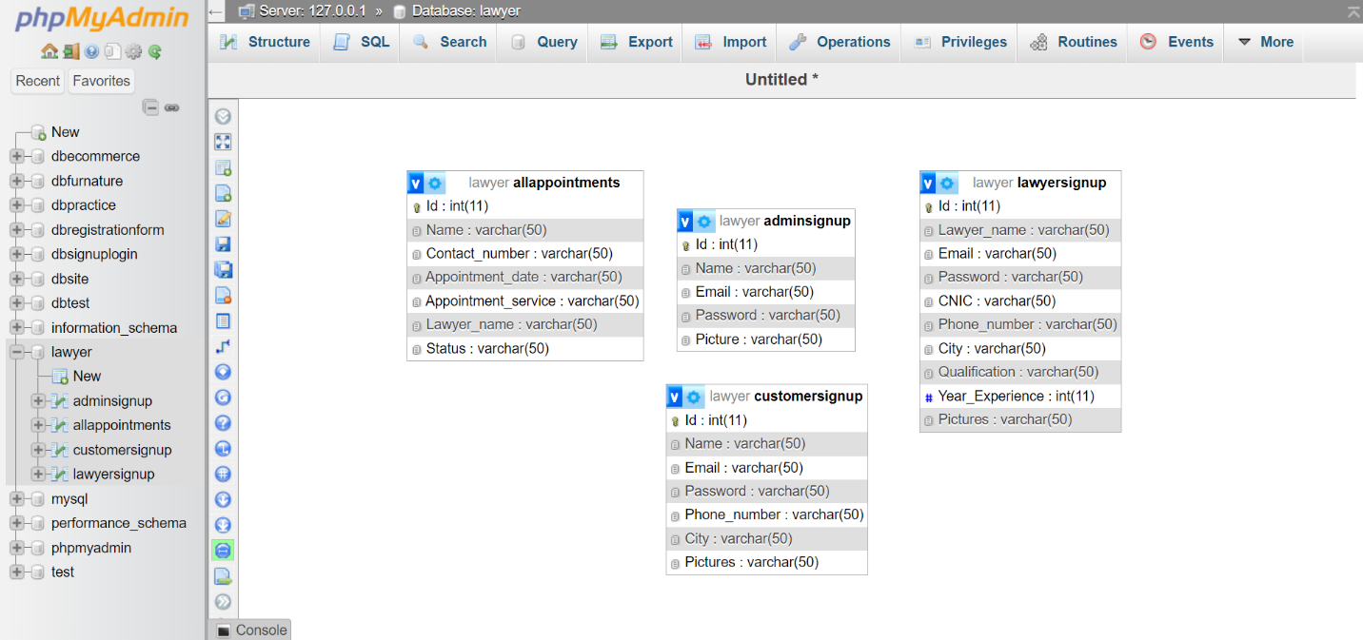

**USER’S GUIDE**

HOME PAGE

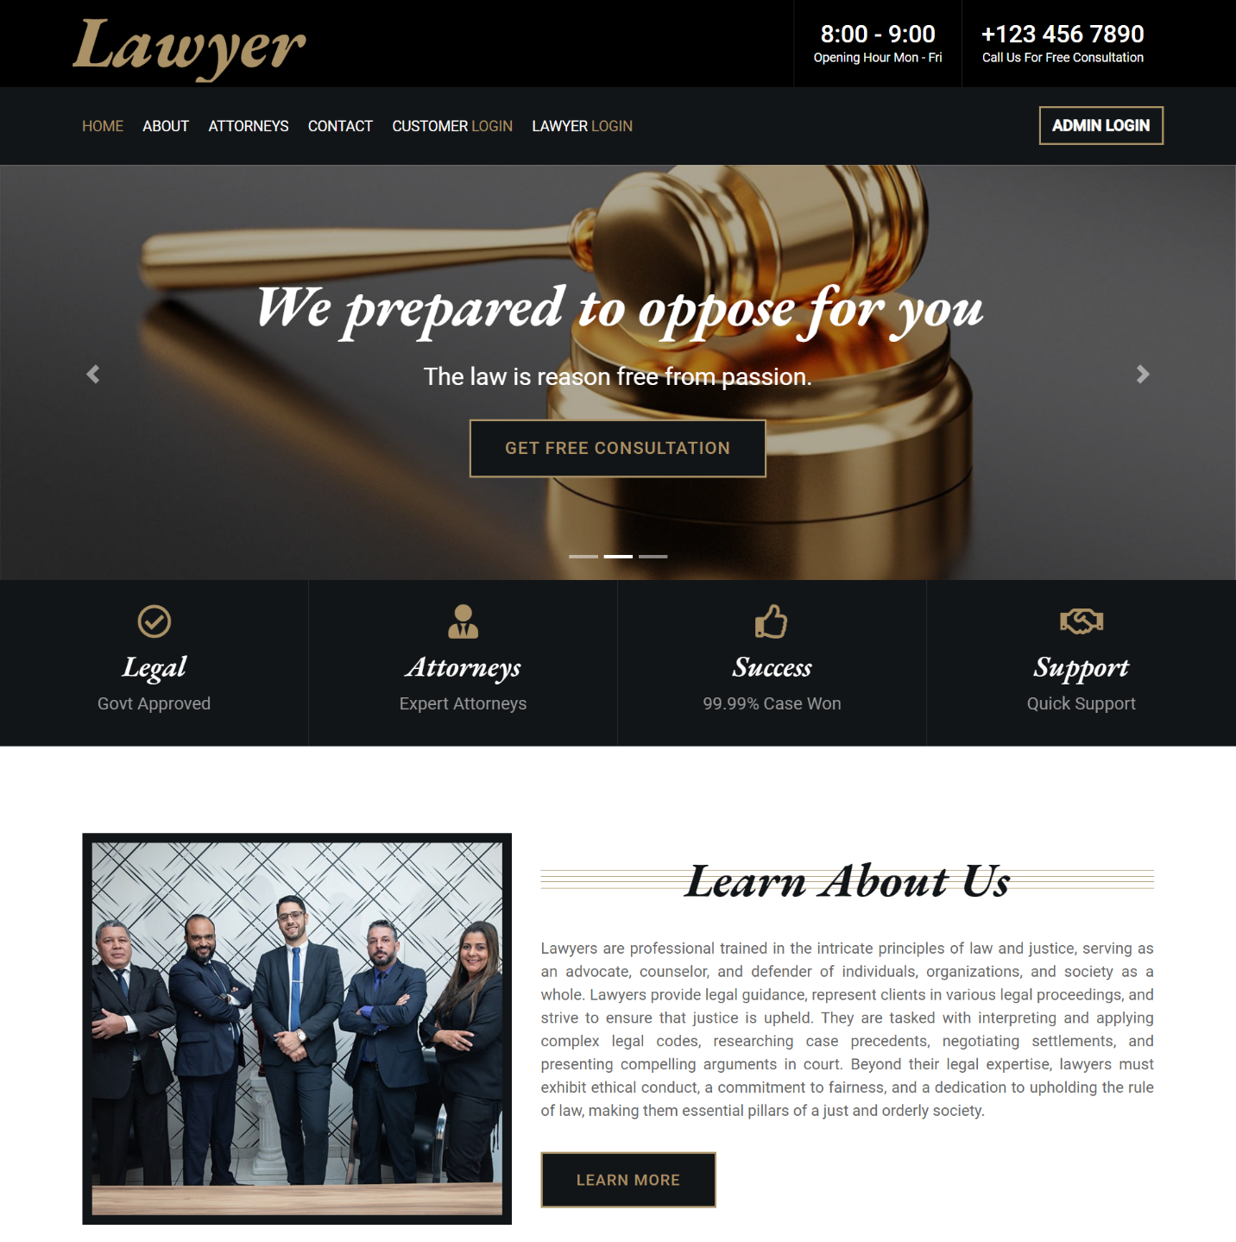

**

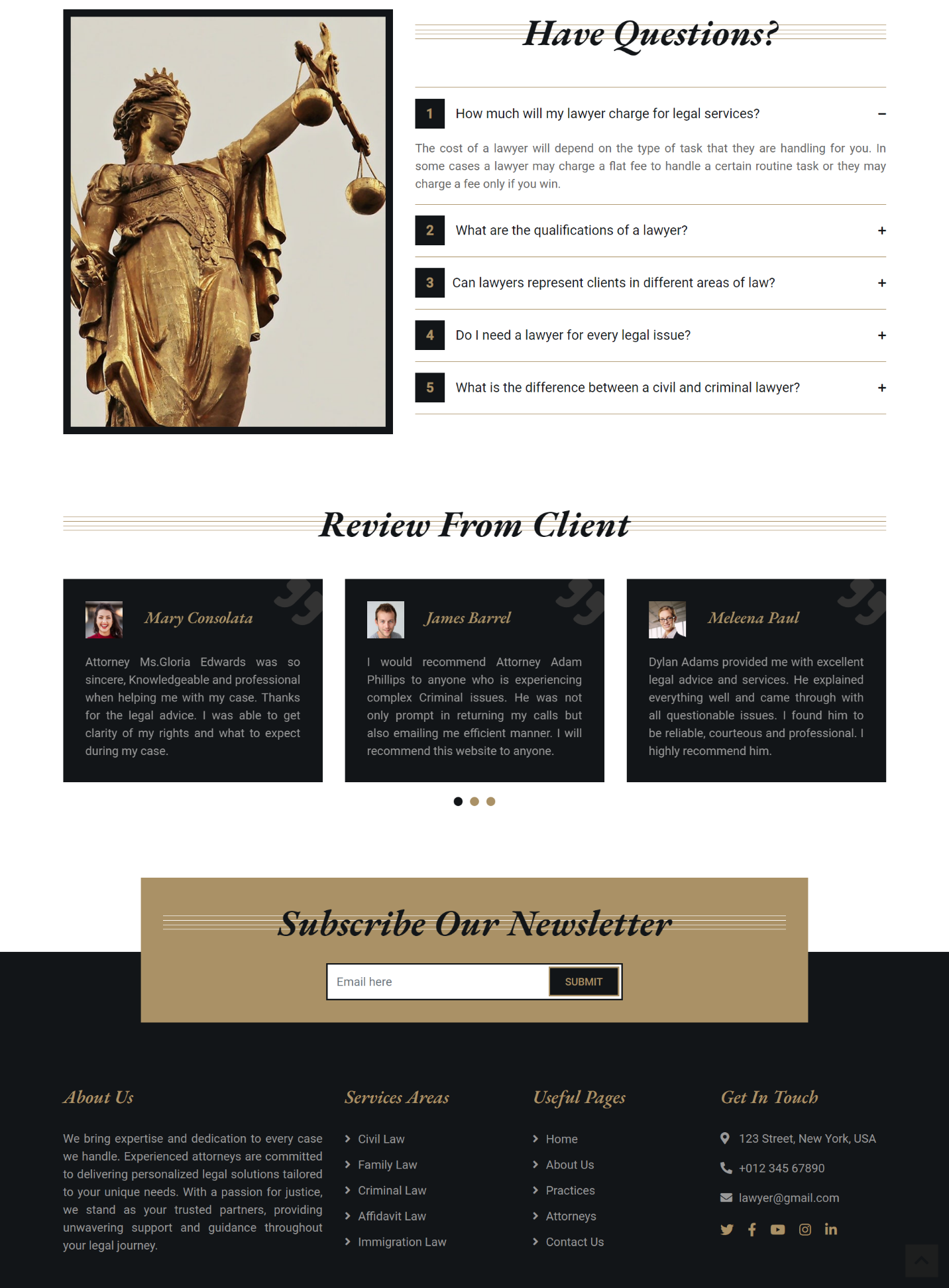

Customer Login

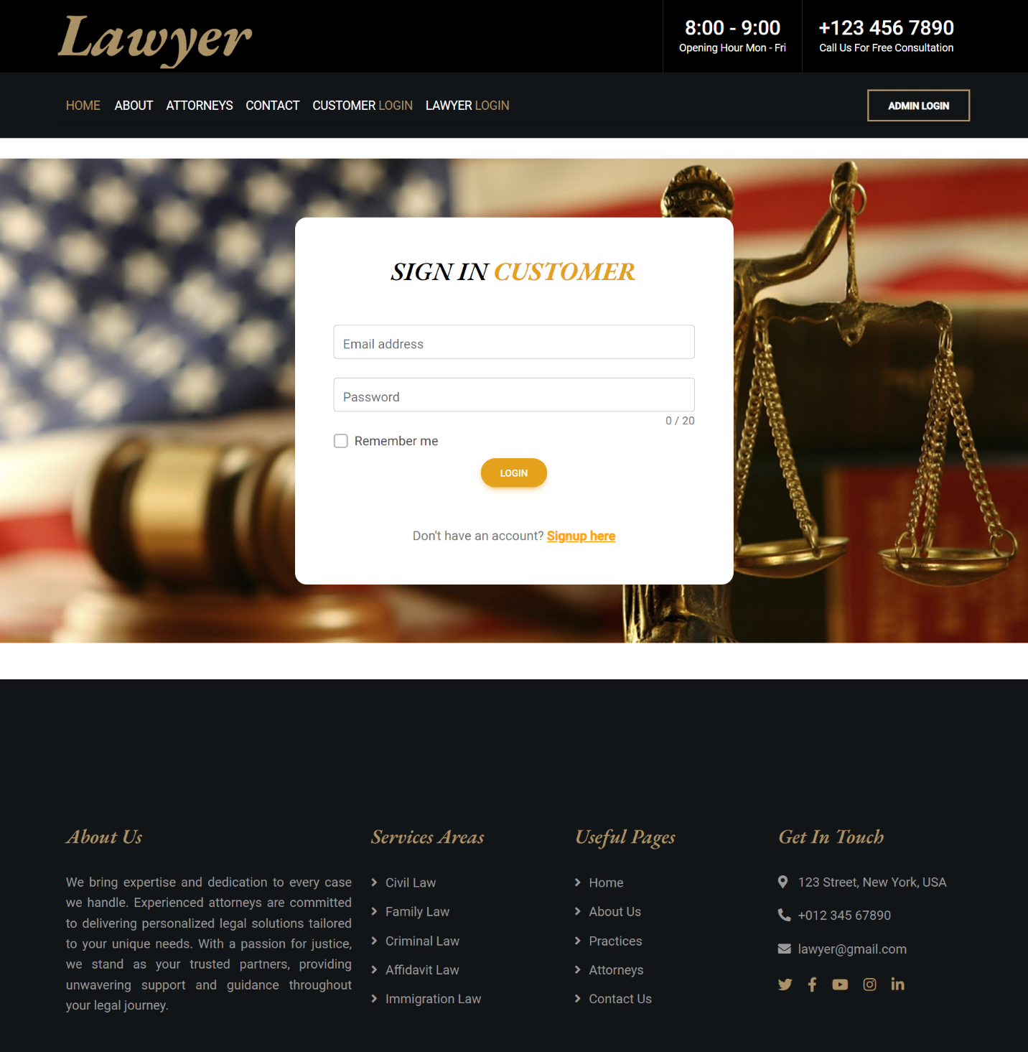

Customer Signup

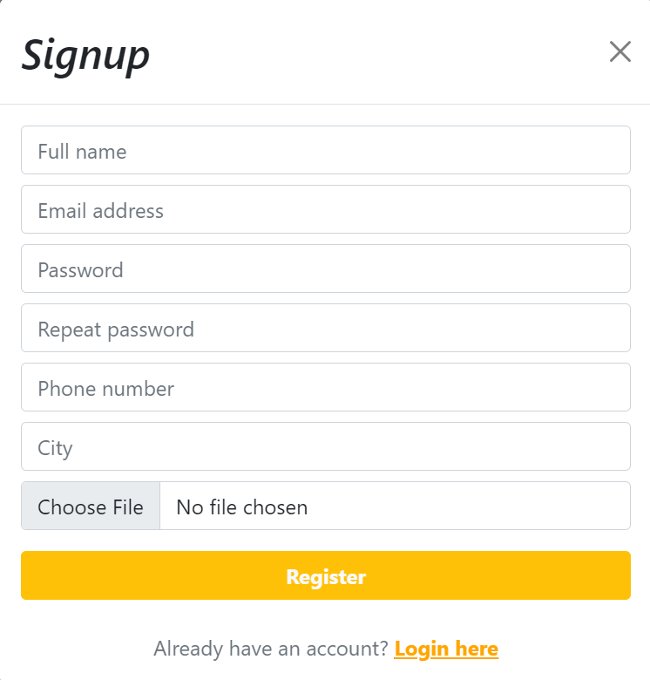

Lawyer Login

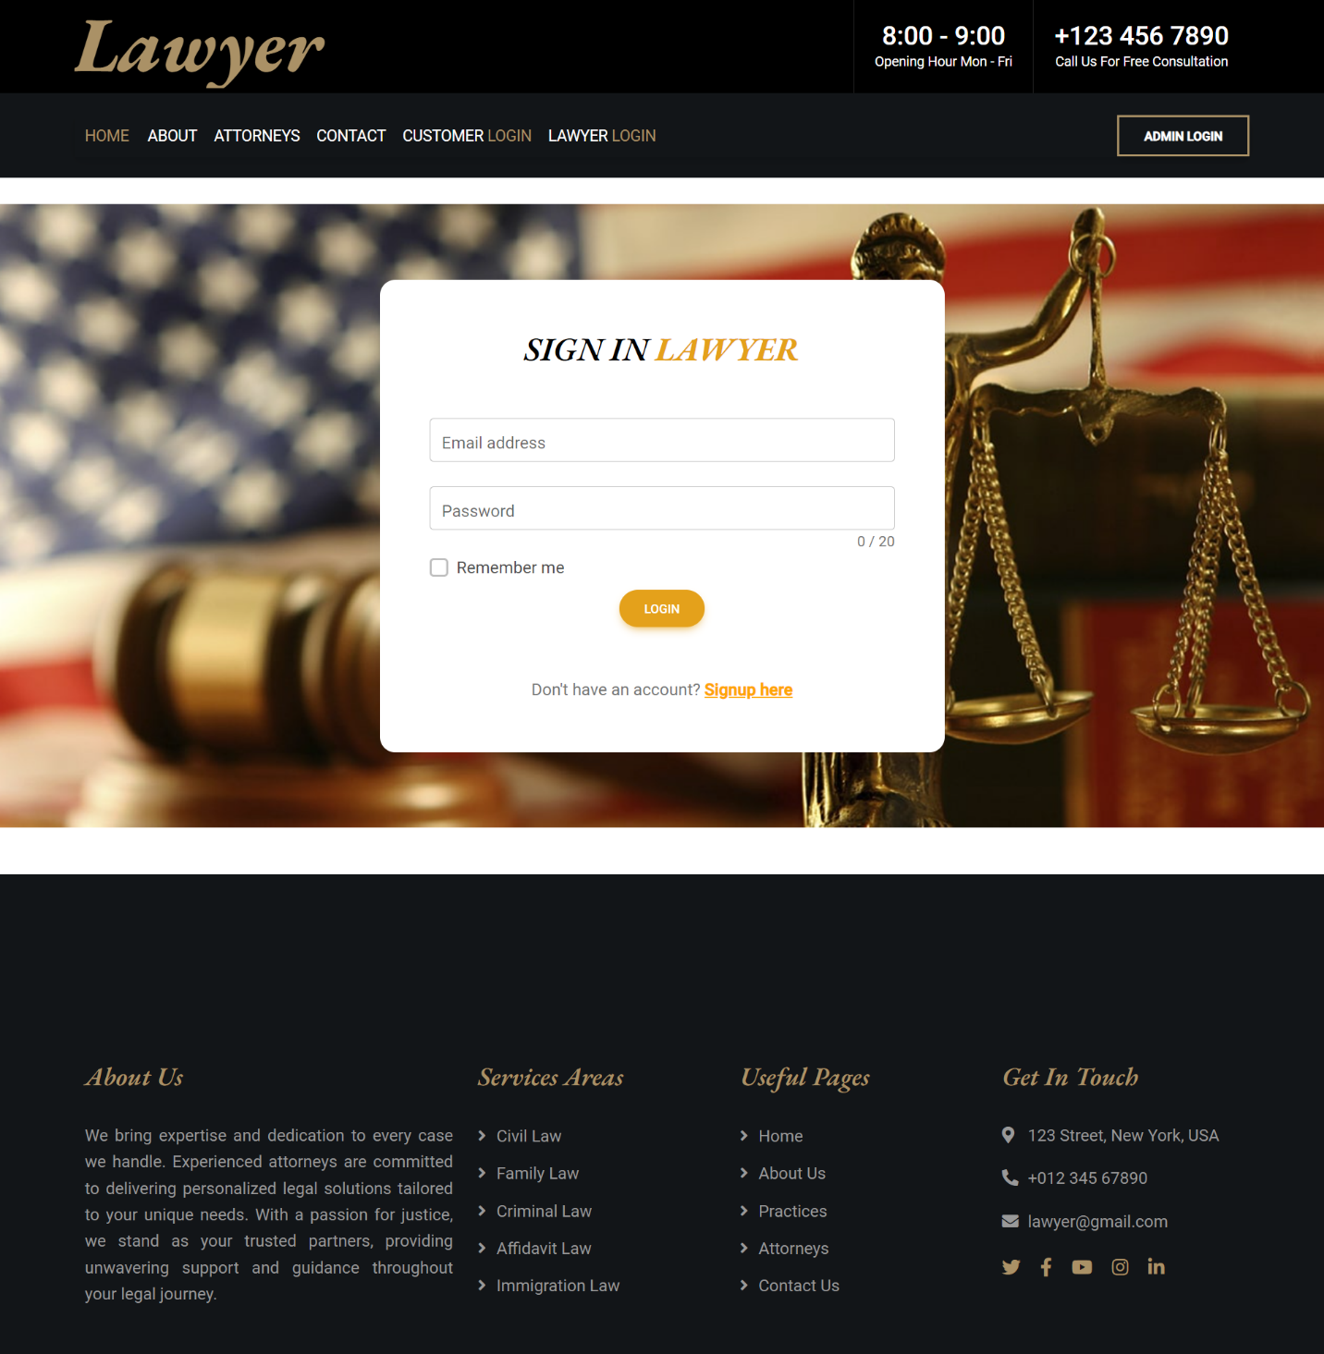

Lawyer Signup

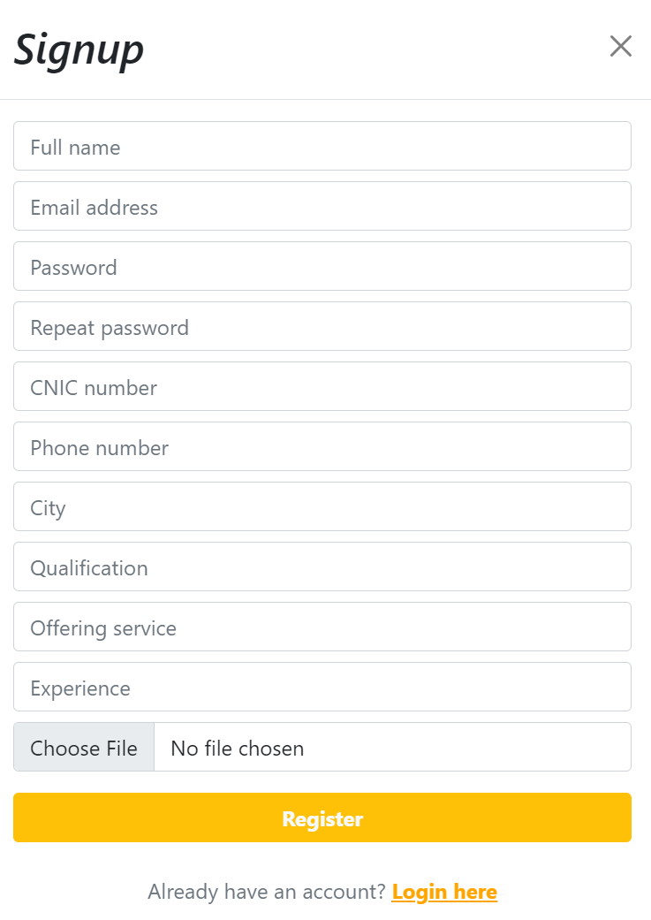

Admin Login

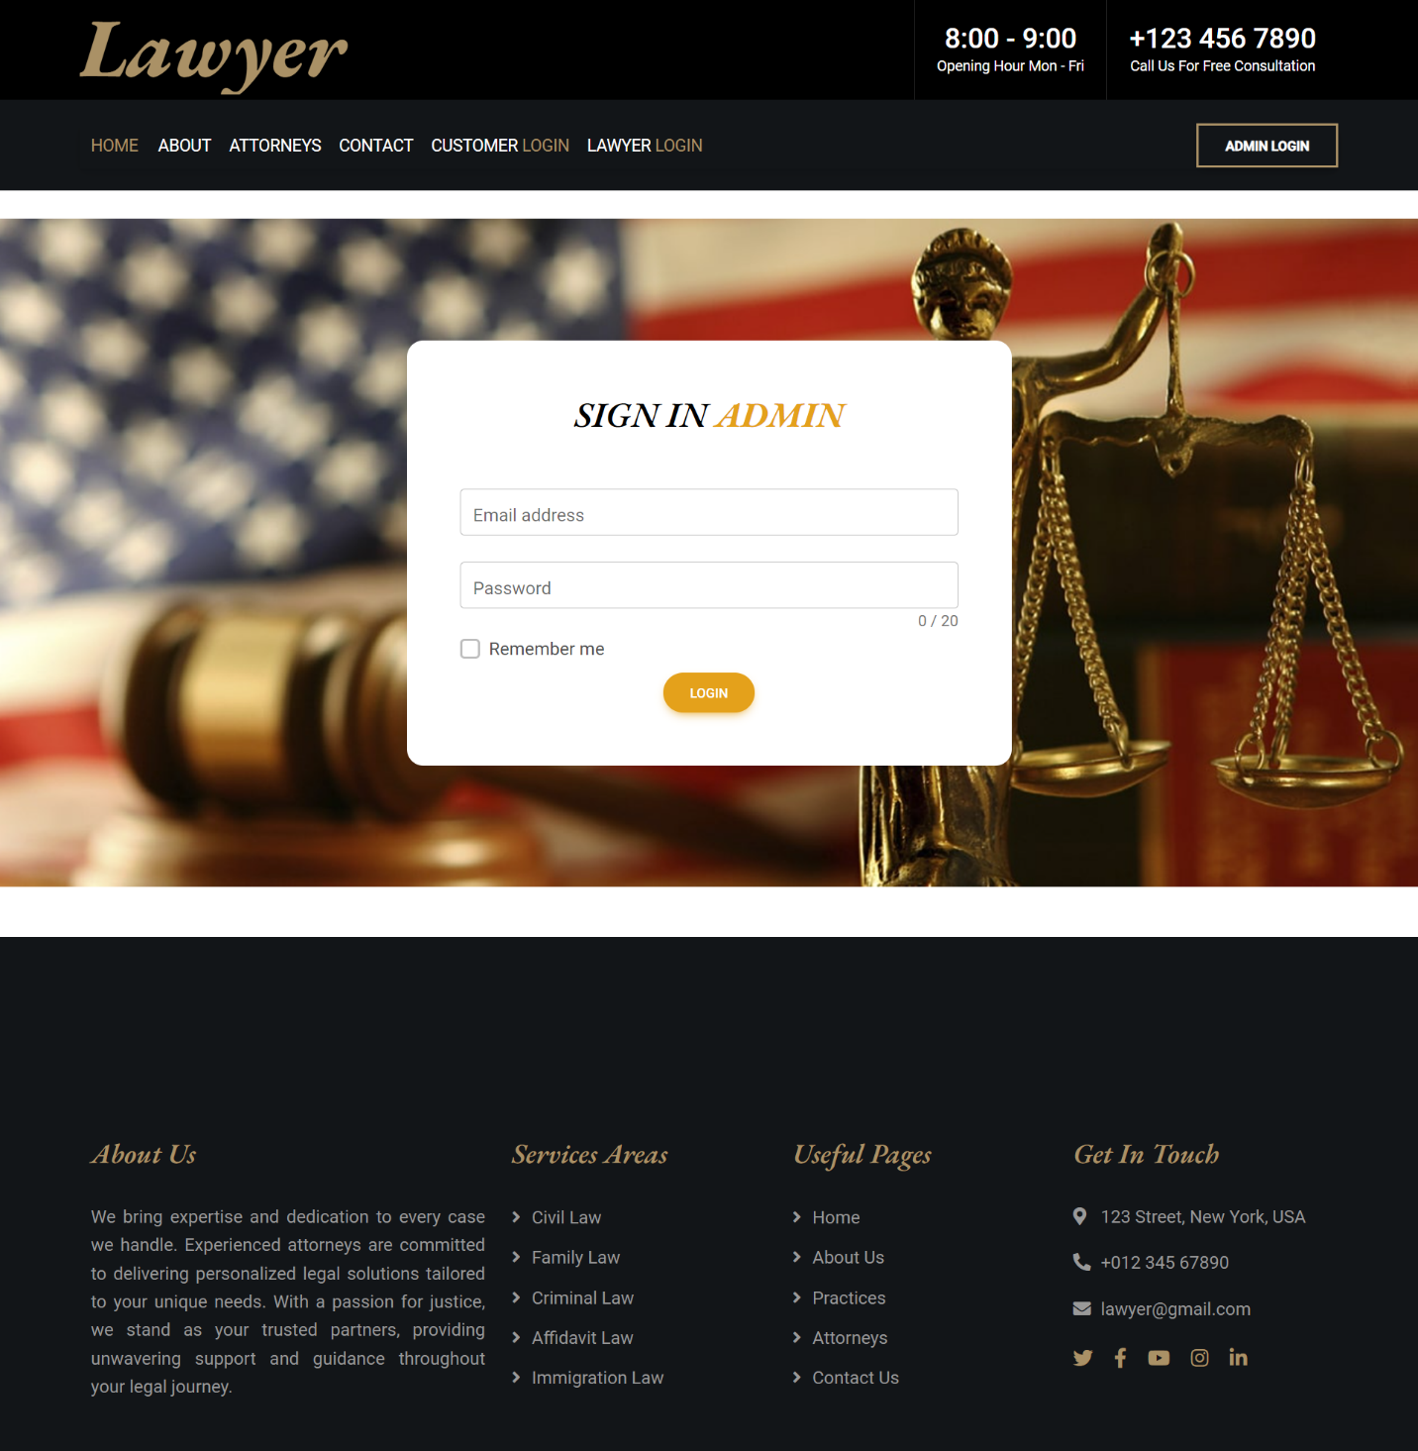

Admin Dashboard

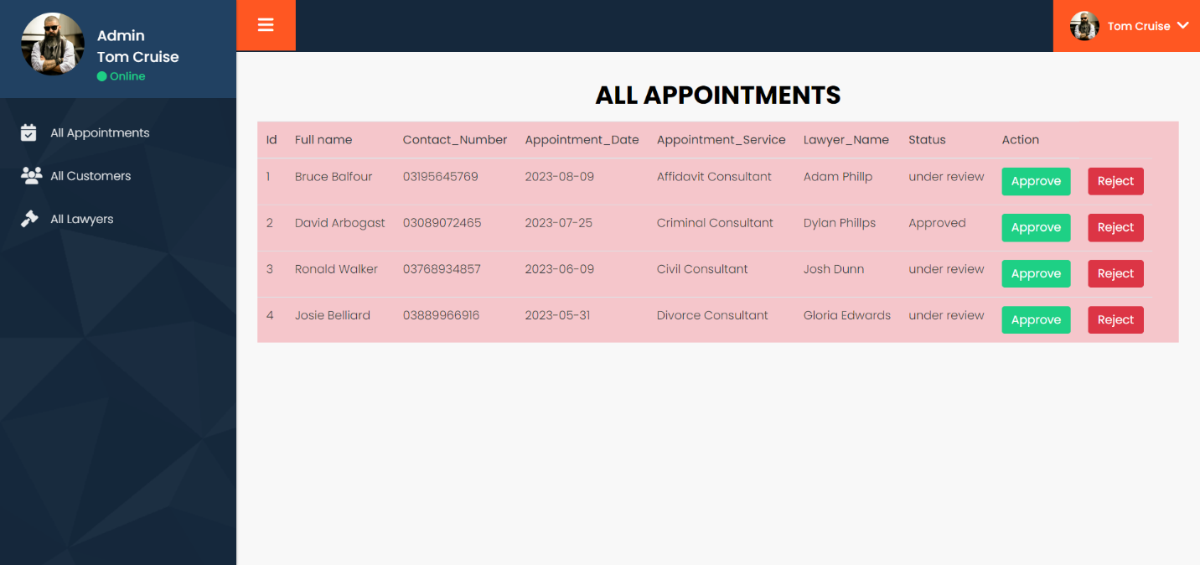

Admin Profile

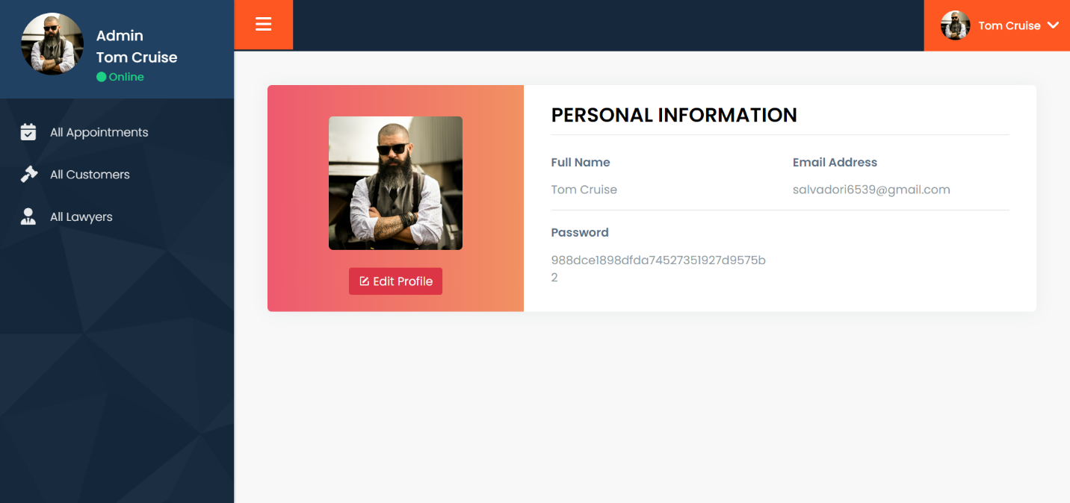

Customer Dashboard

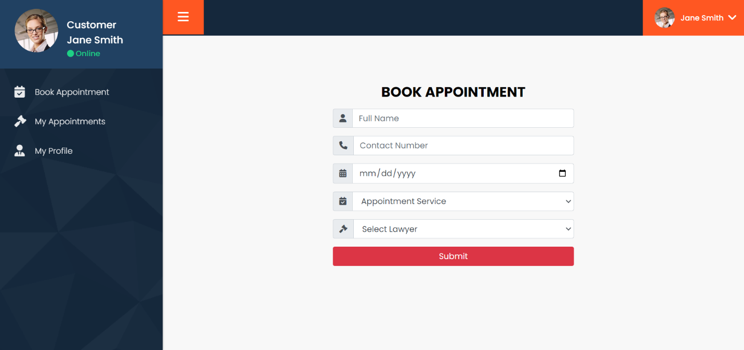

Customer Profile

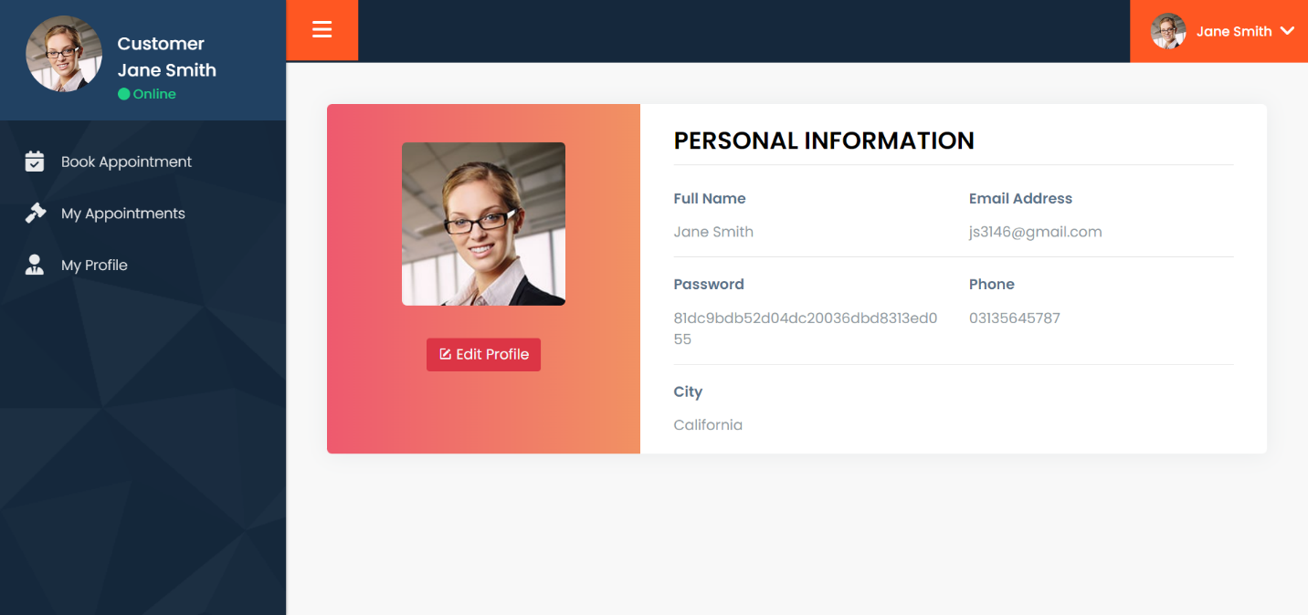

Lawyer Dashboard

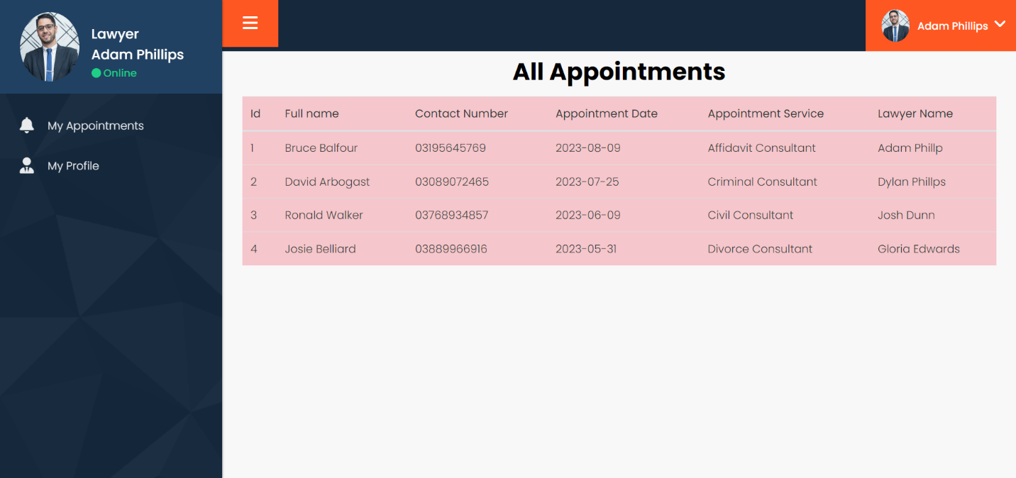

Lawyer Profile

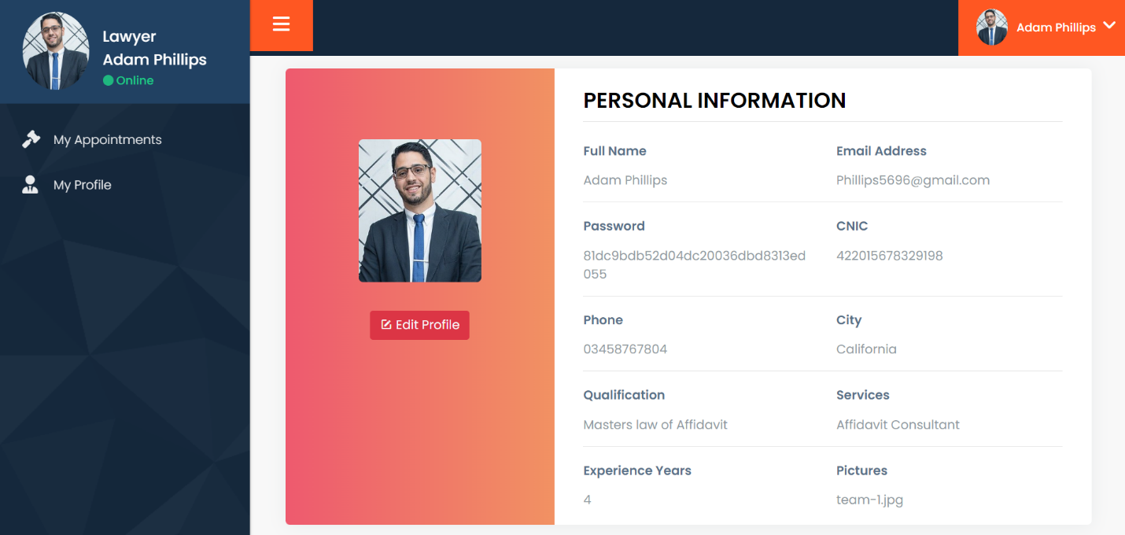

Update Profile Customer

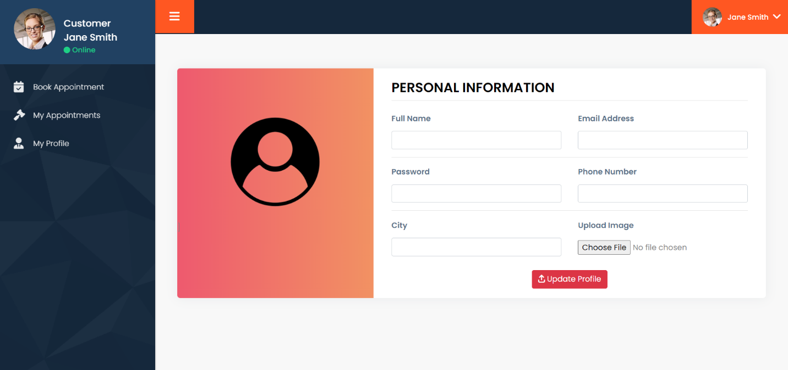

Update Profile Lawyer

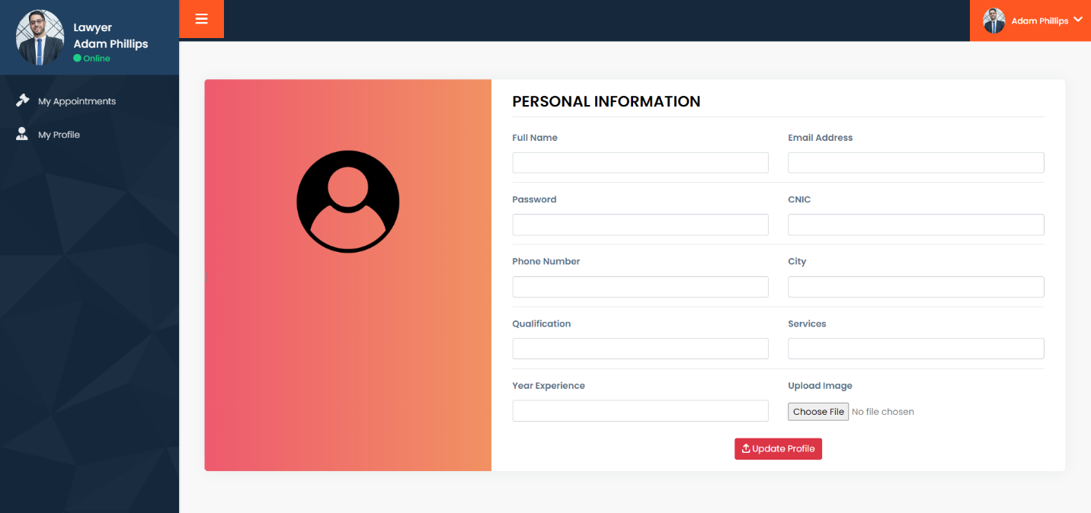

**Developer’s Guide**

Header

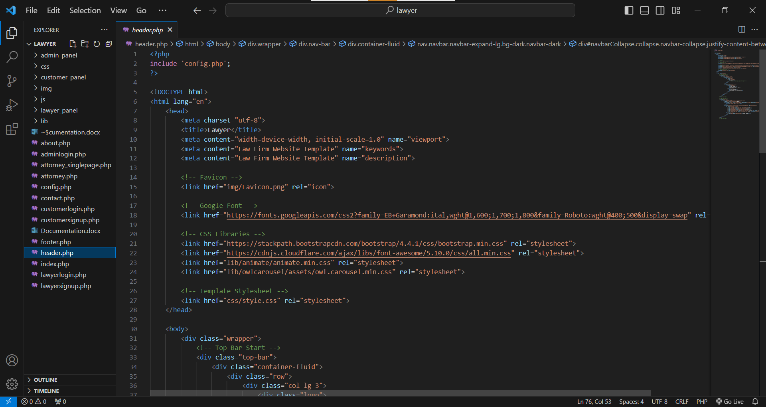

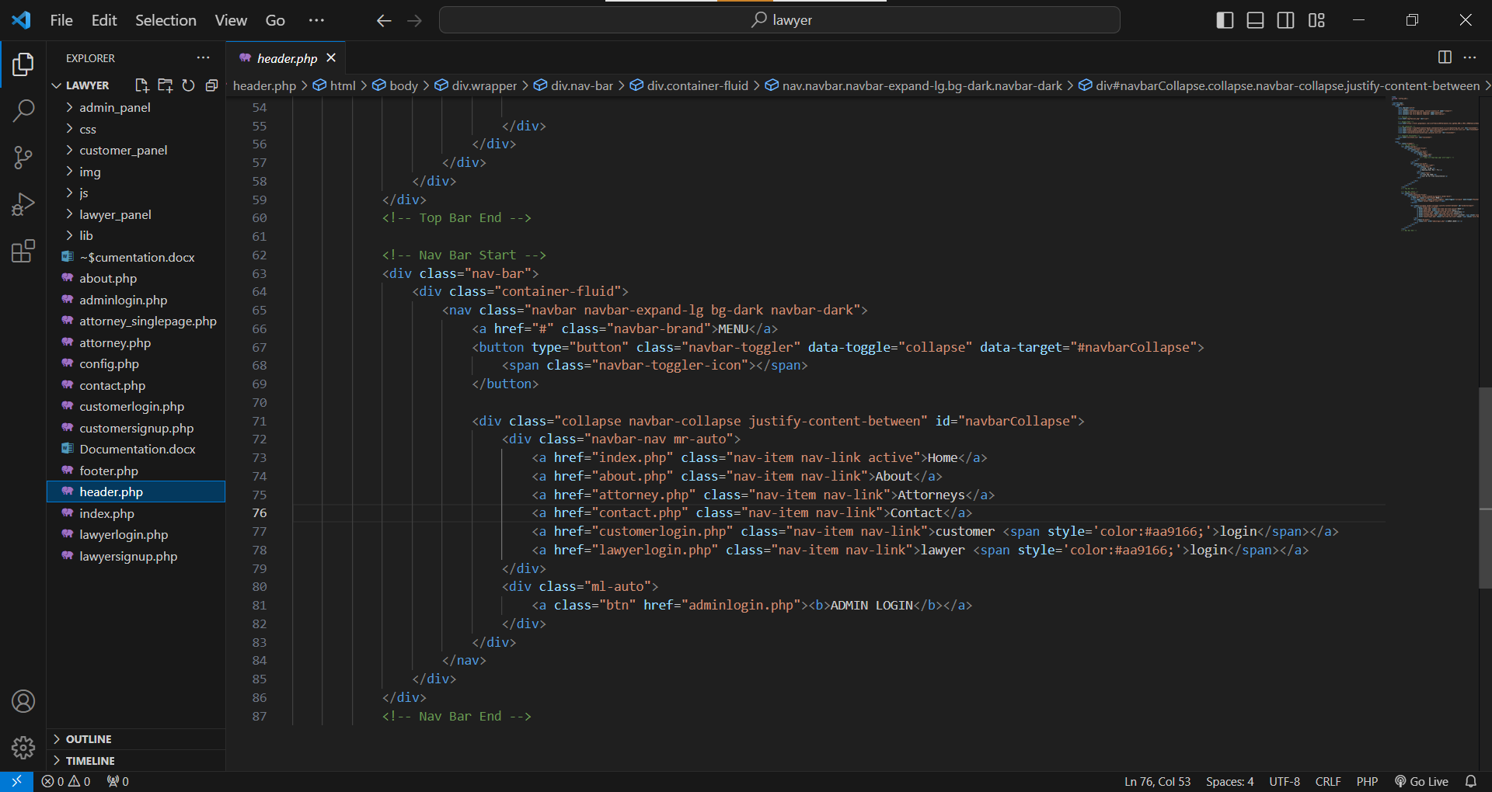

FOOTER

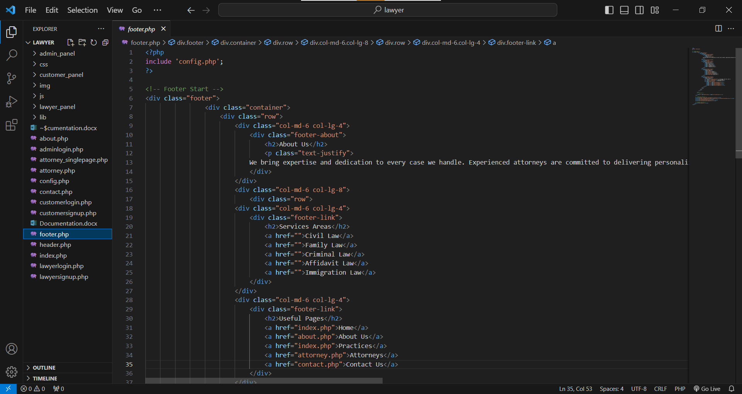

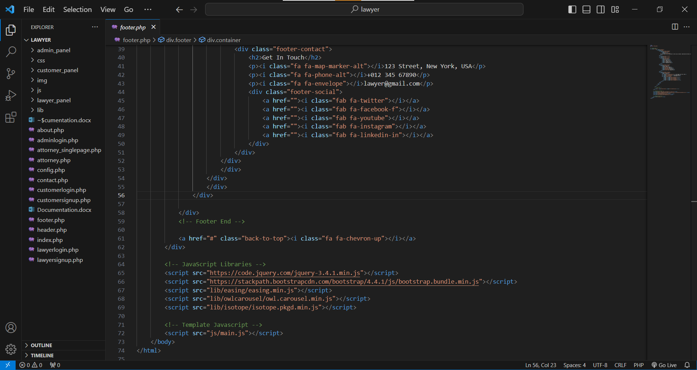

Admin Login

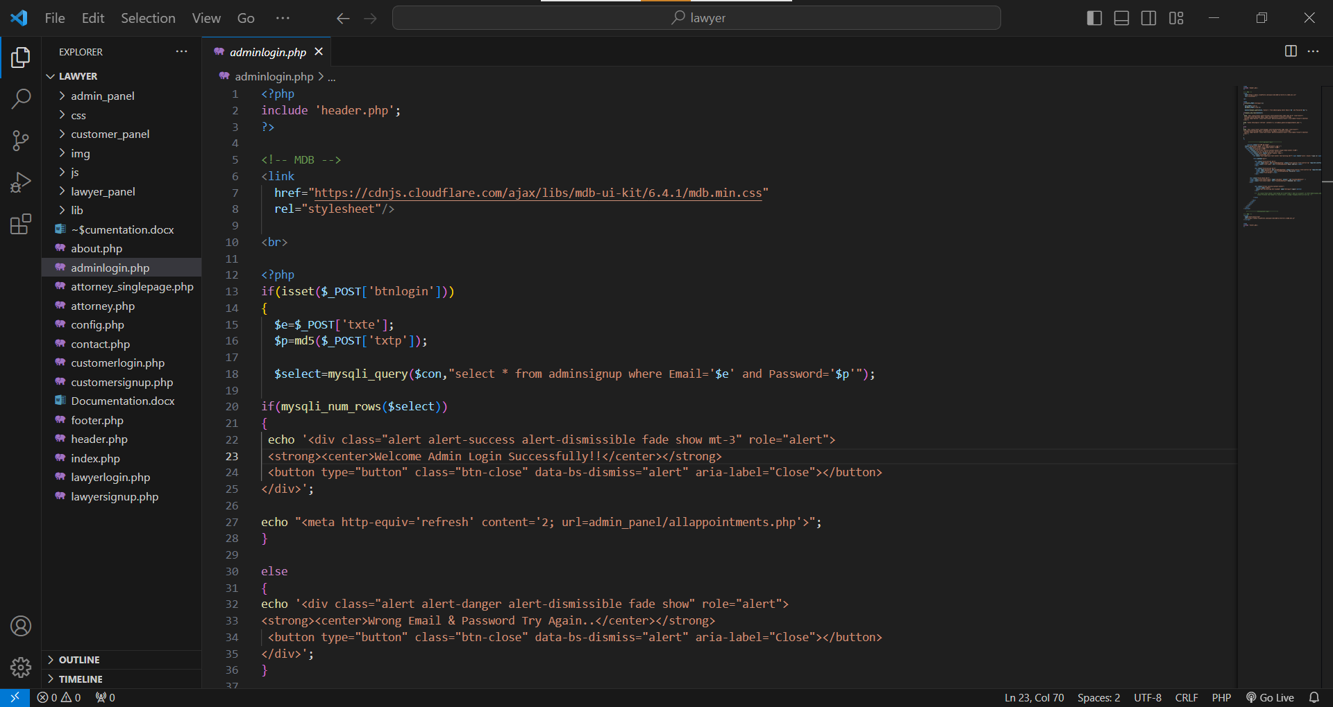

Customer Login

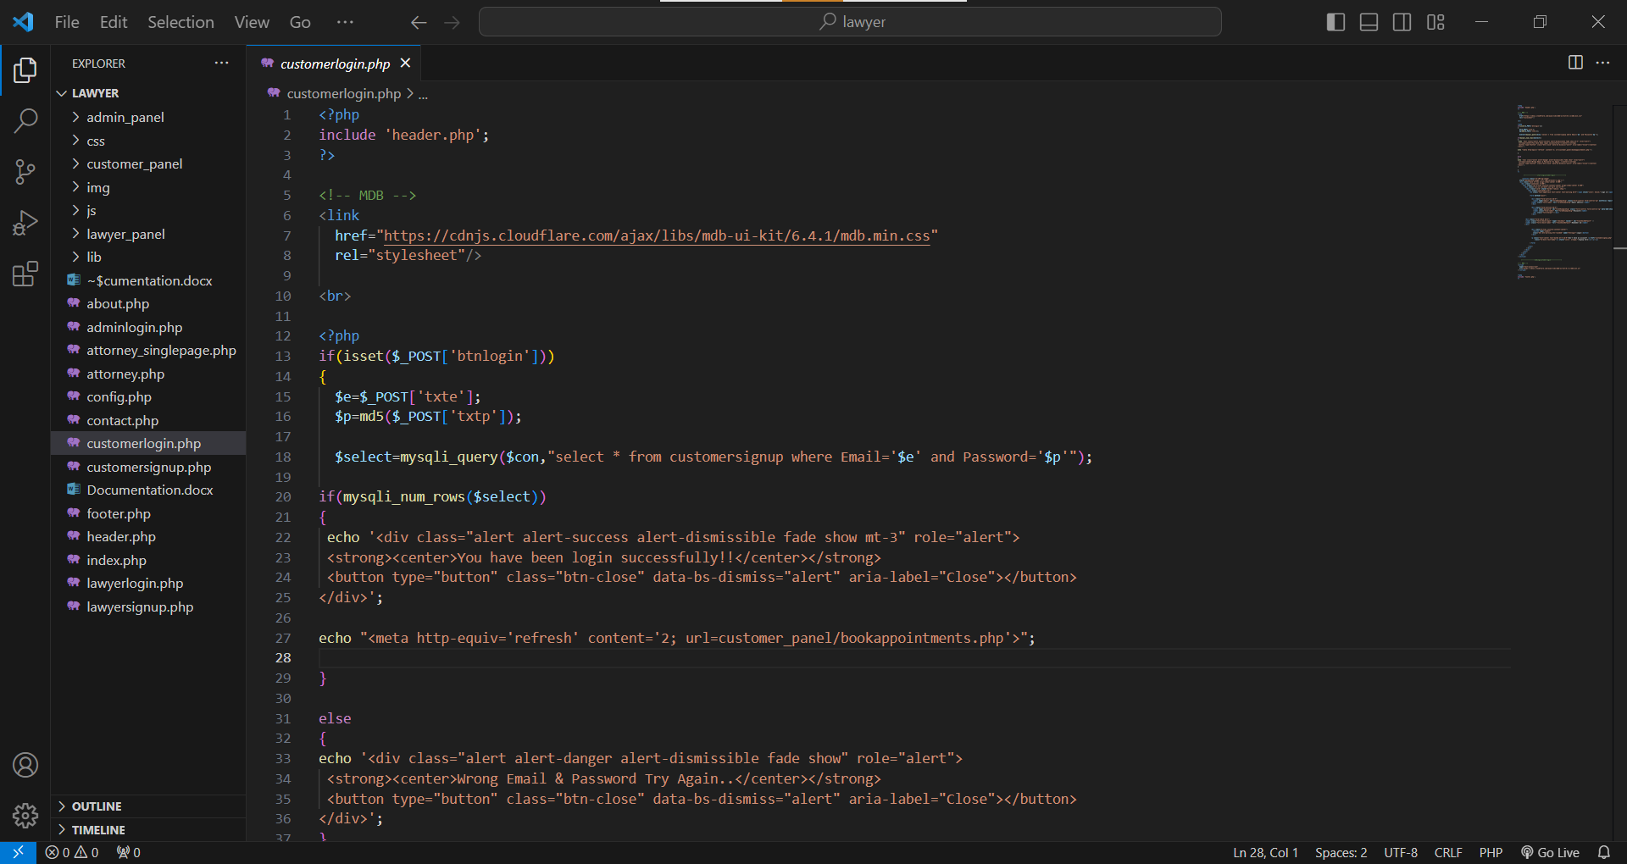

Customer Signup

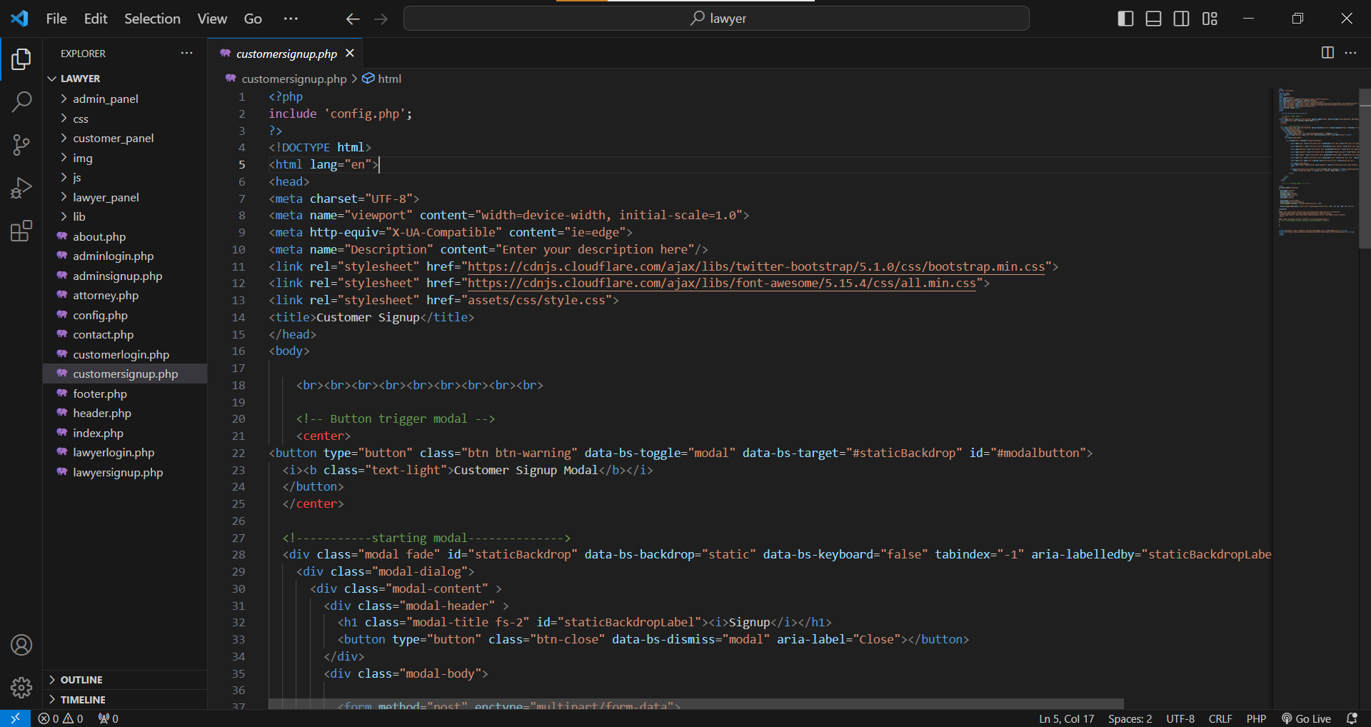

Lawyer Login

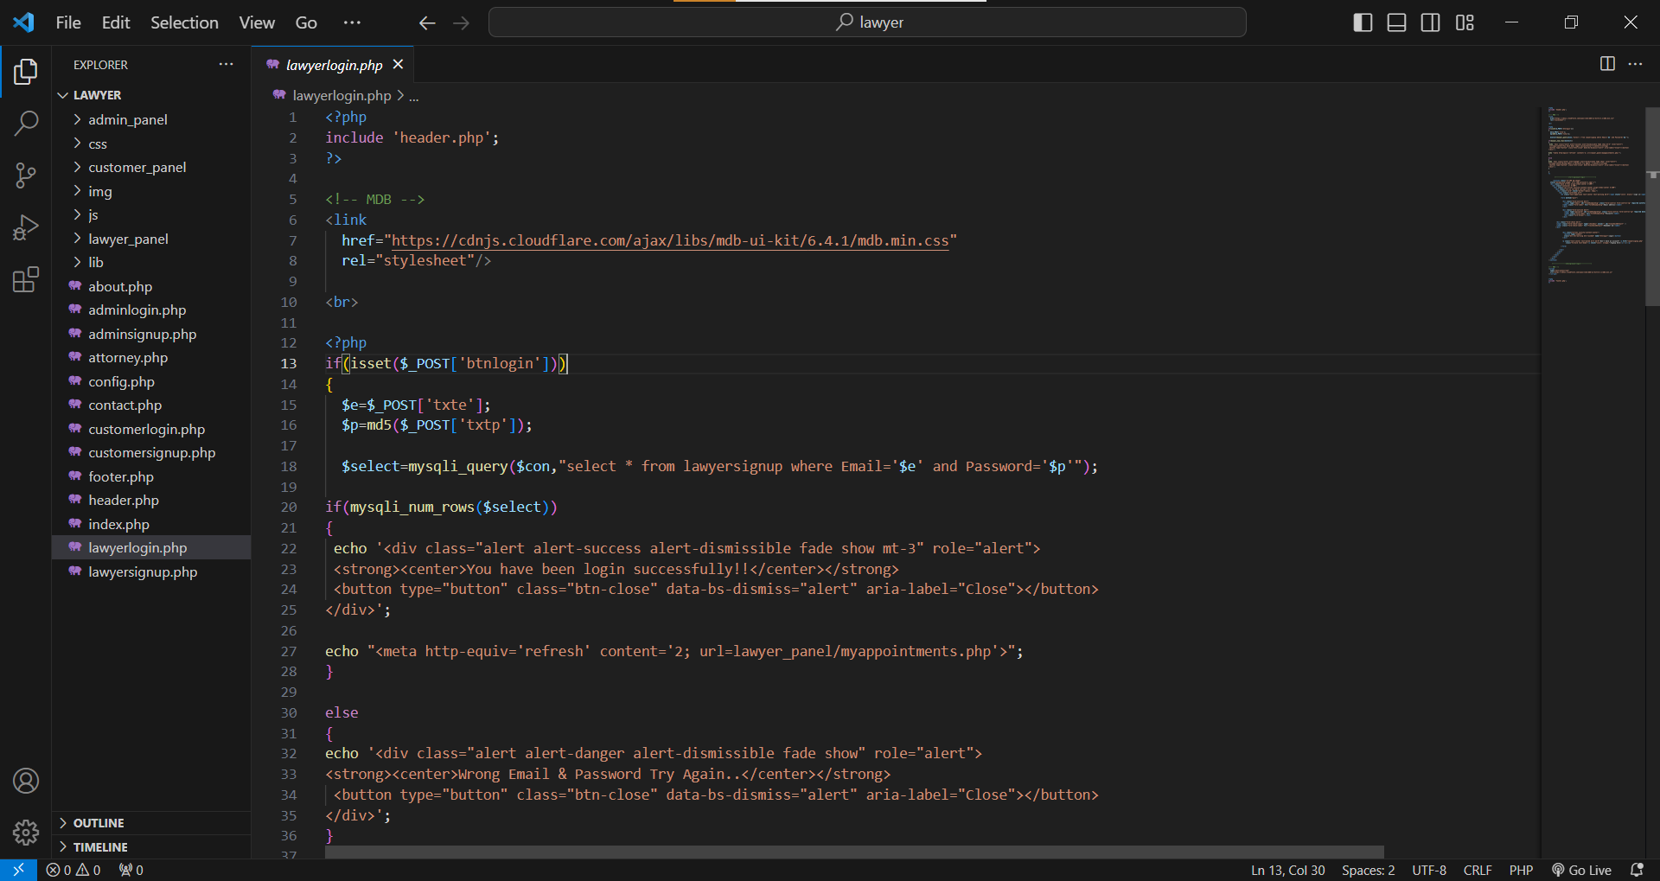

Lawyer Signup

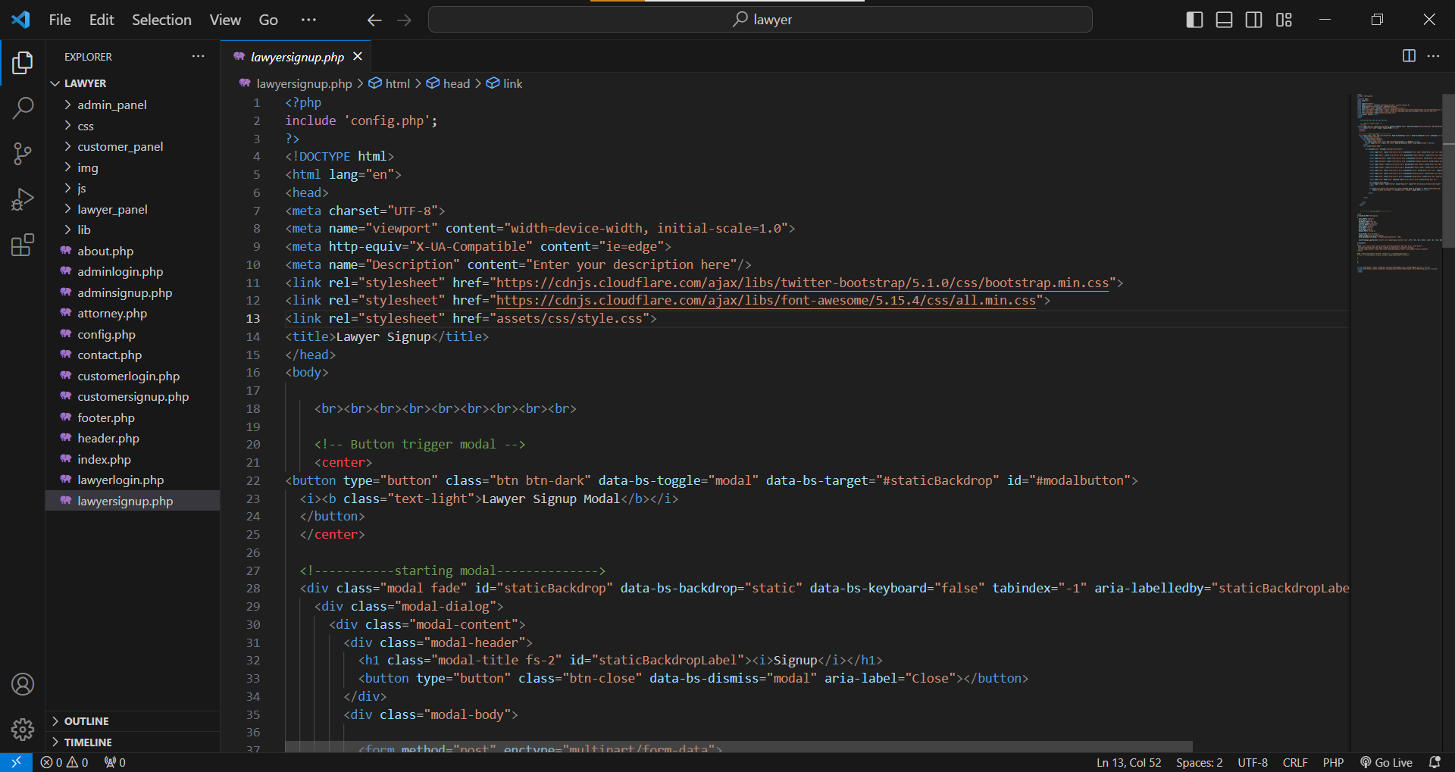

**Developer Guide (Admin Panel)**

All Appointments

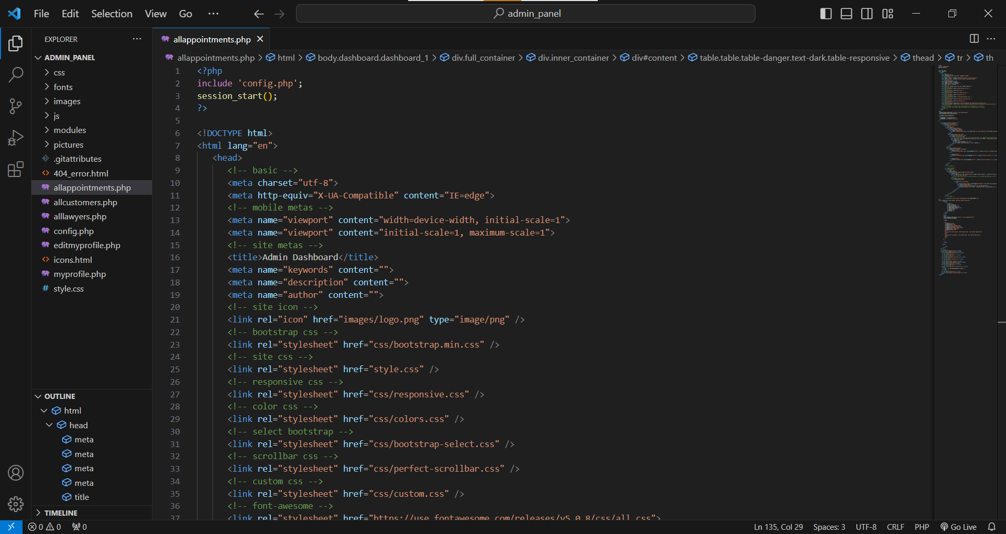

All Customers

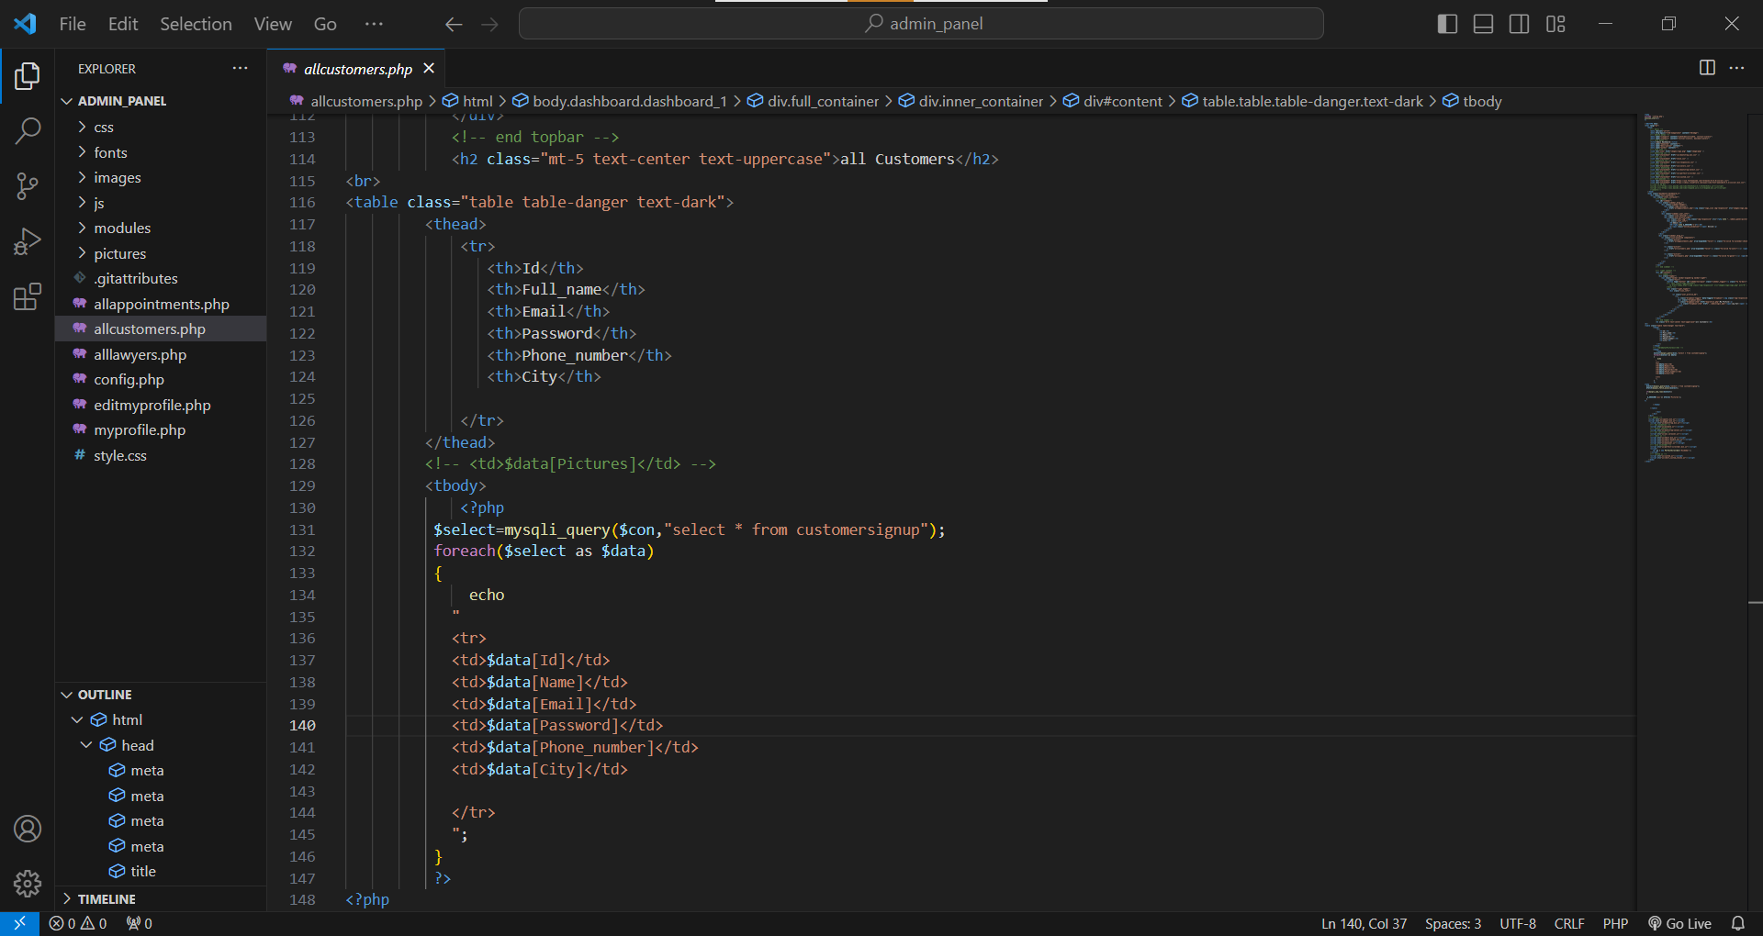

All Lawyers

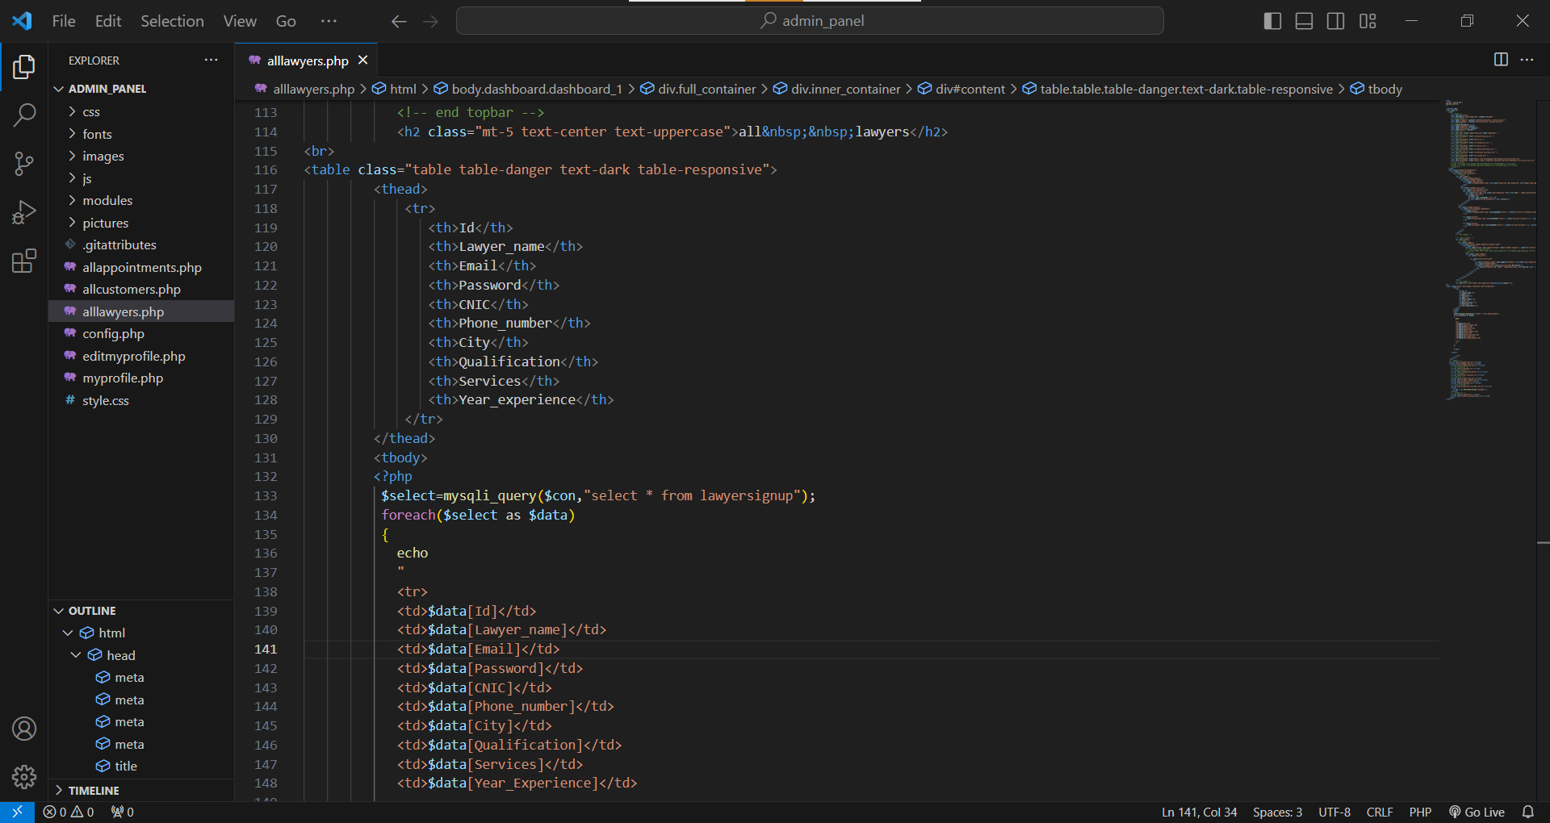

Profile

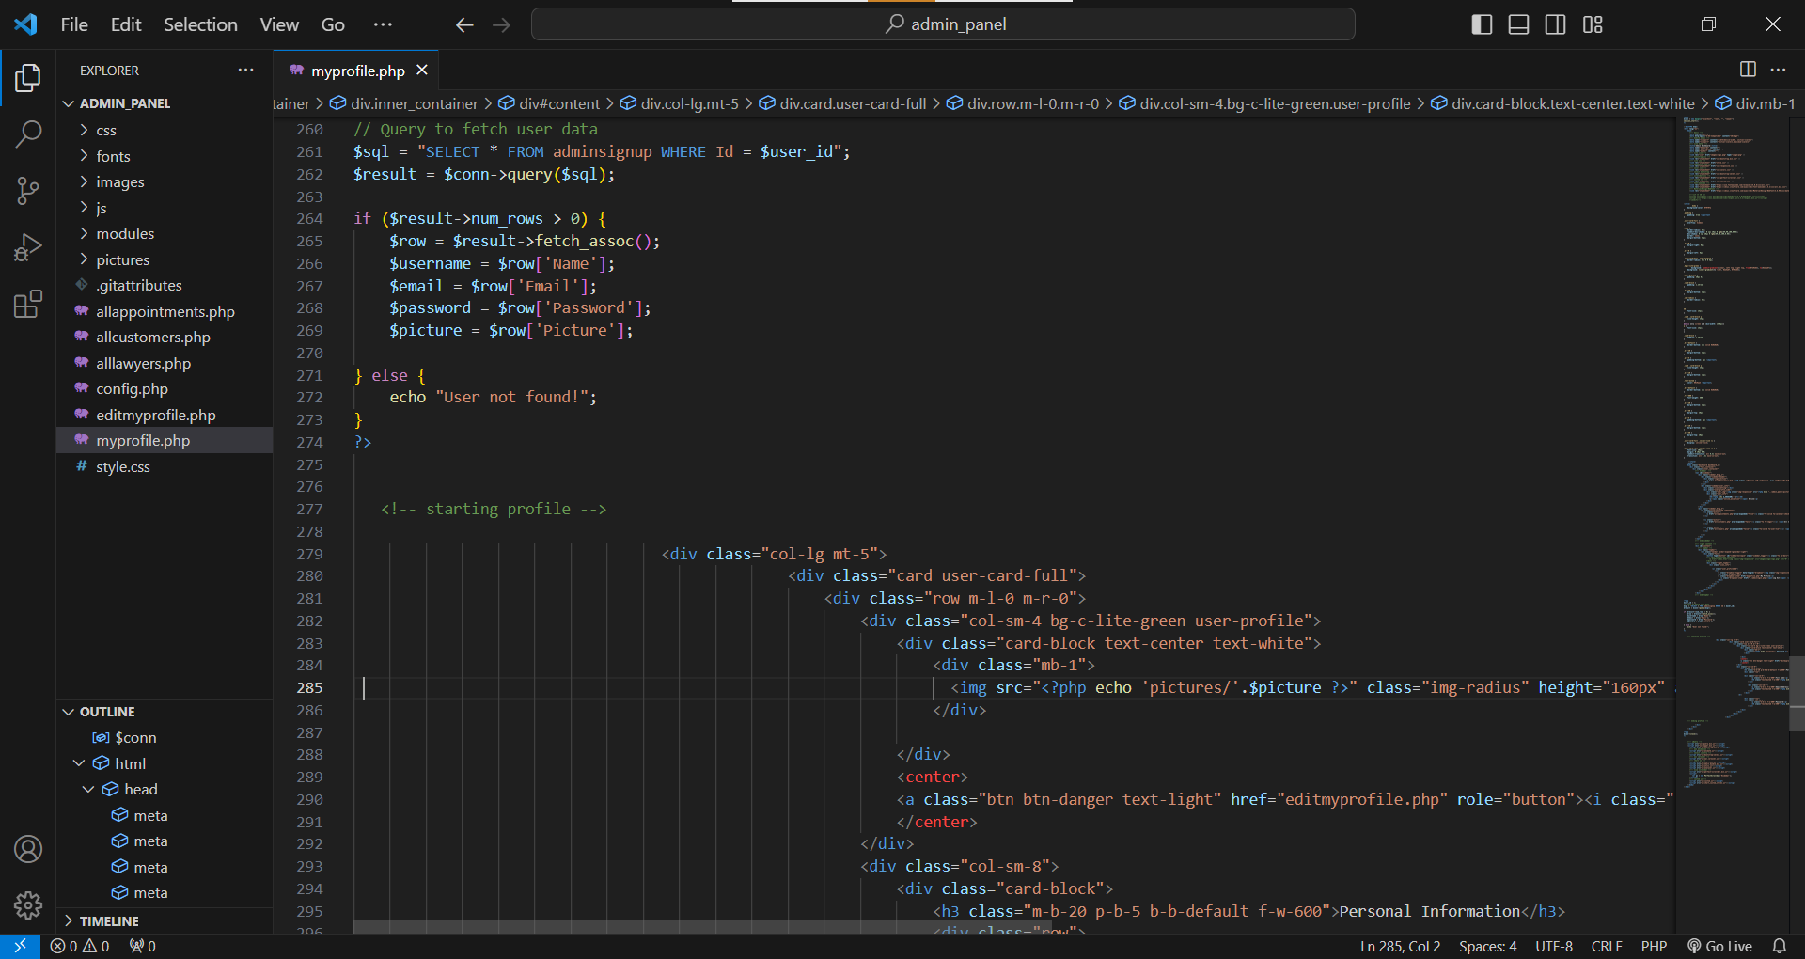

Update Profile

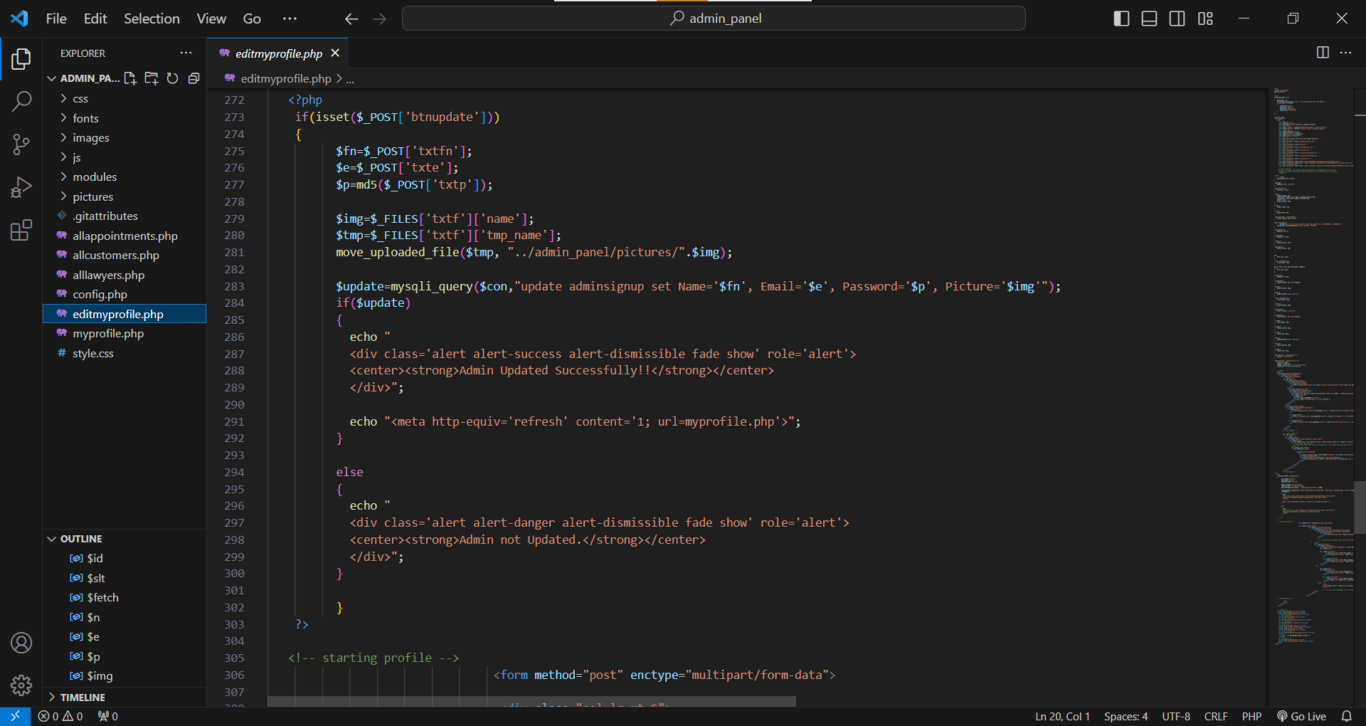

Logout

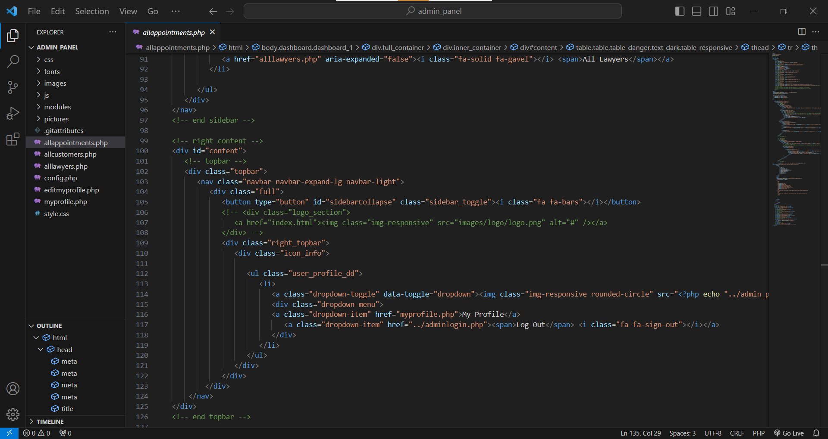

**Developer Guide (Customer Panel)**

Book Appointment

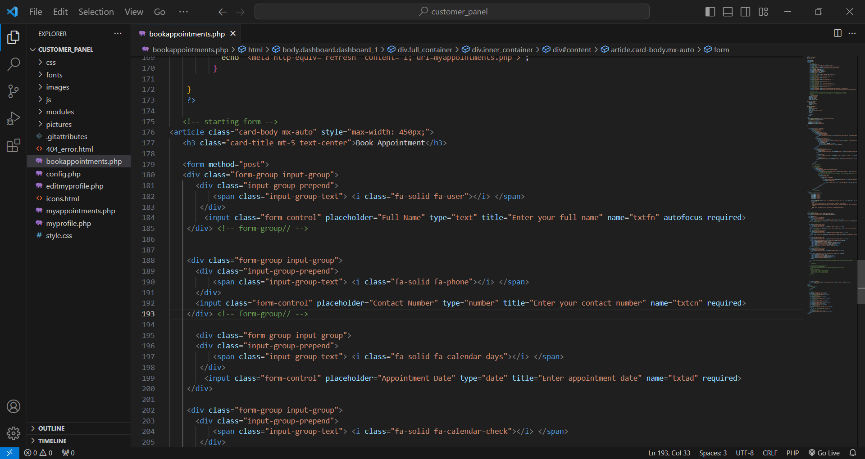

My Appointment

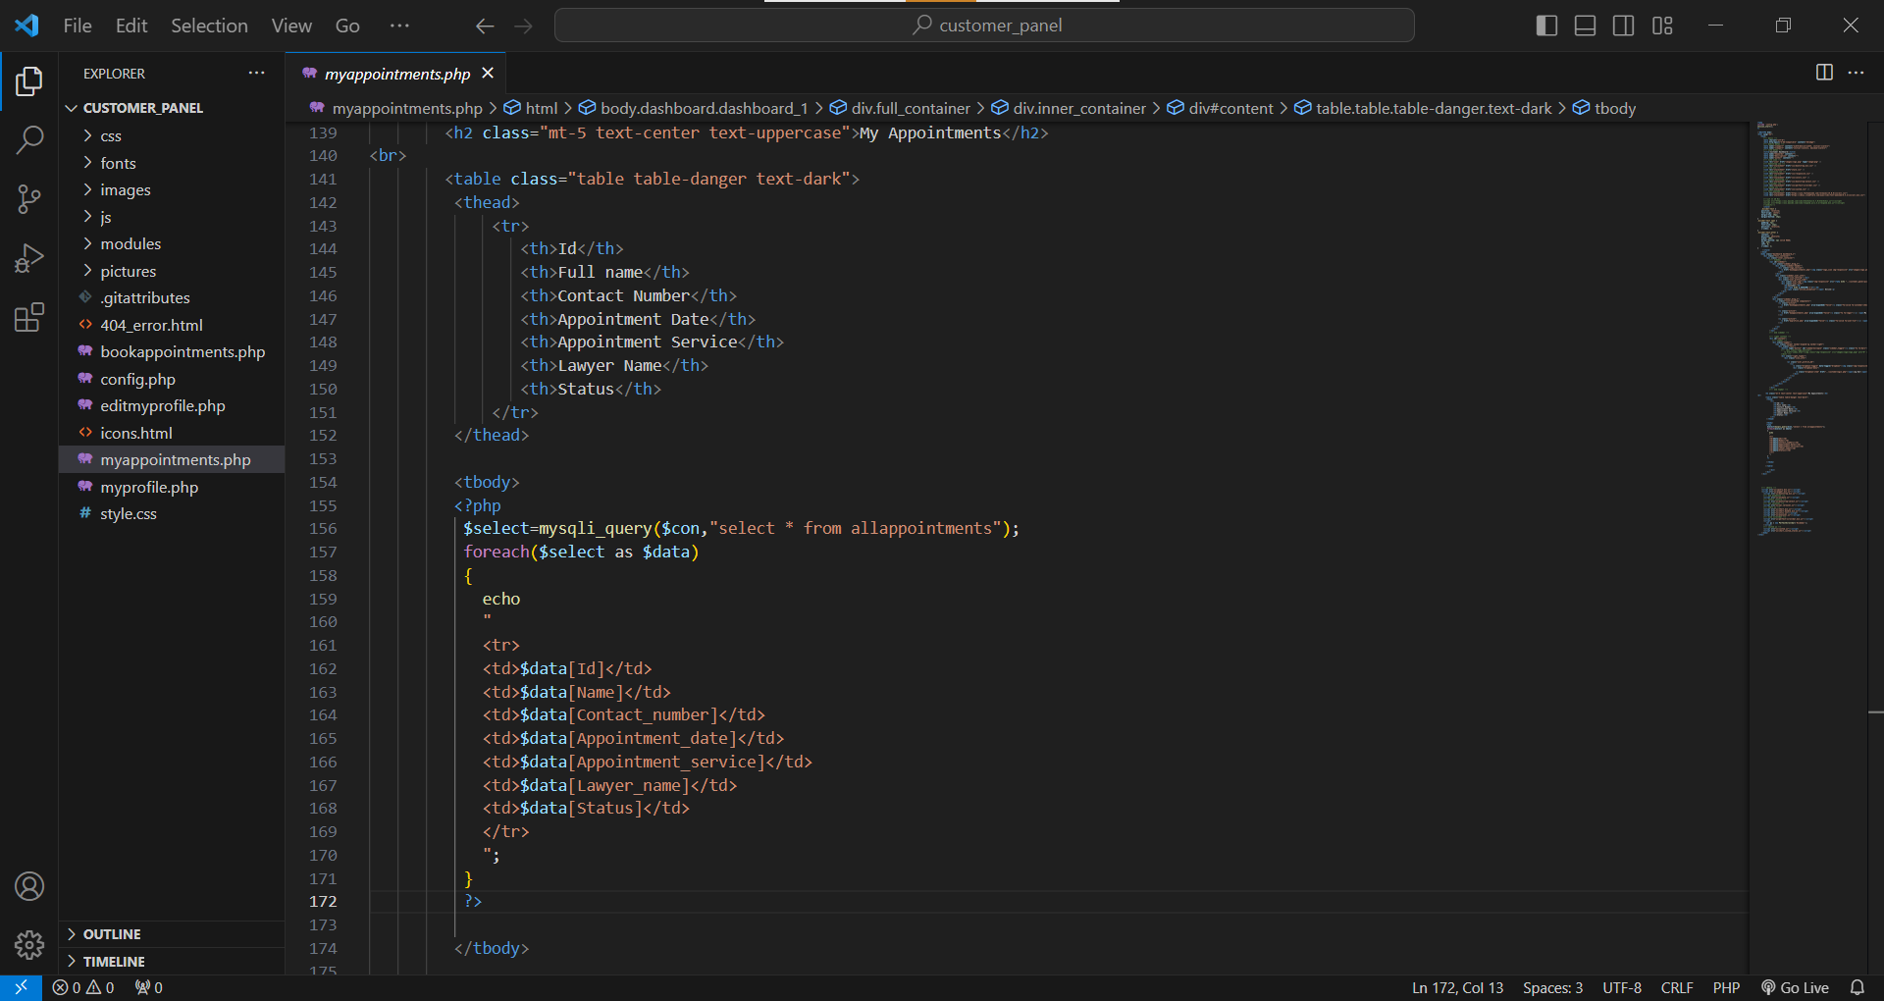

Profile

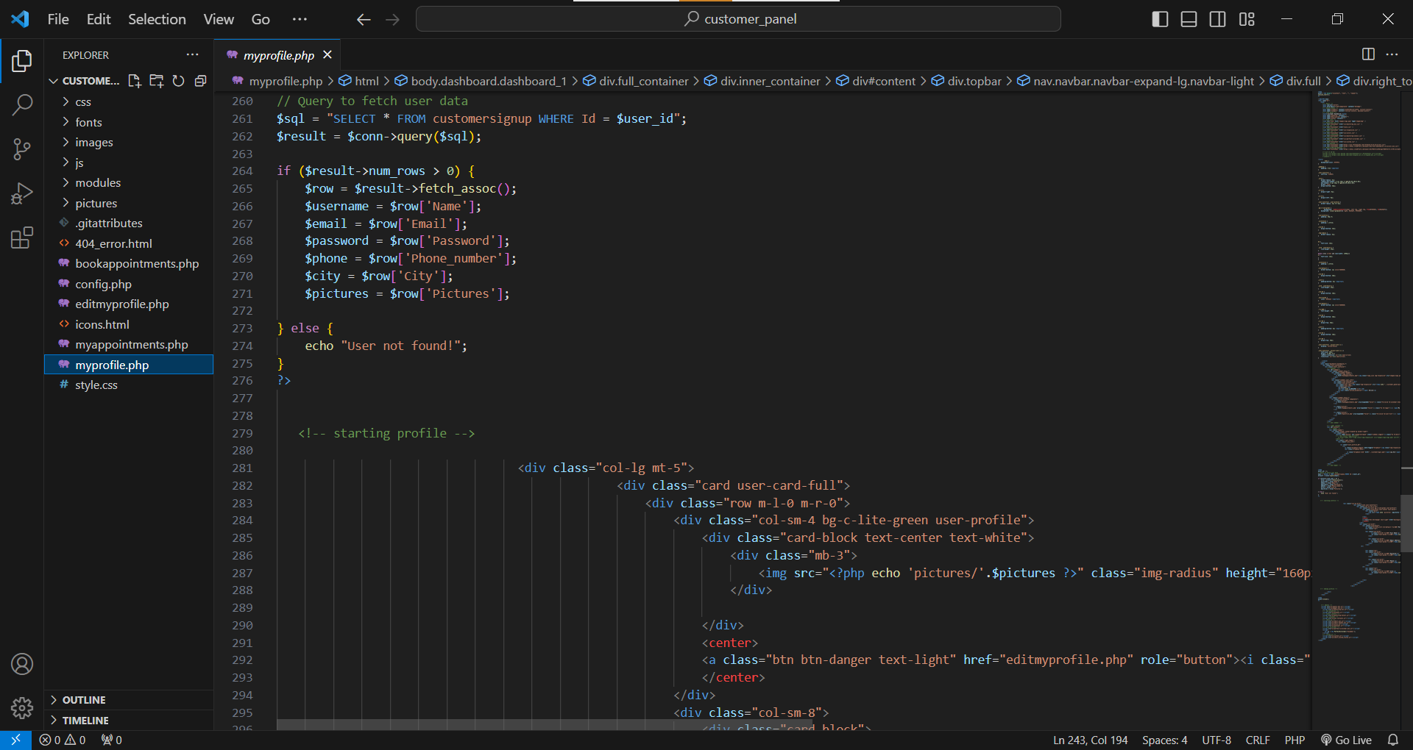

Update Profile

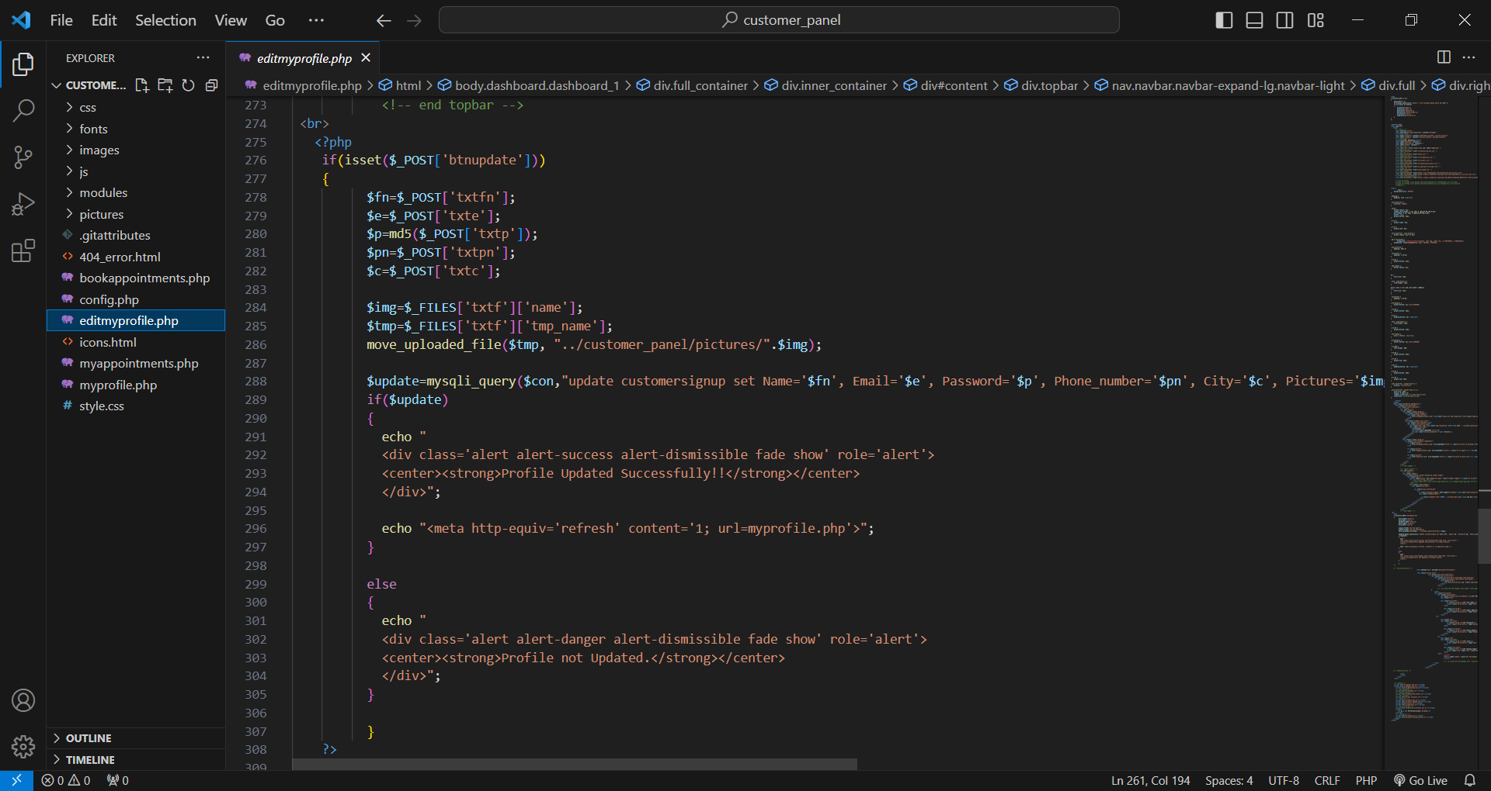

Logout

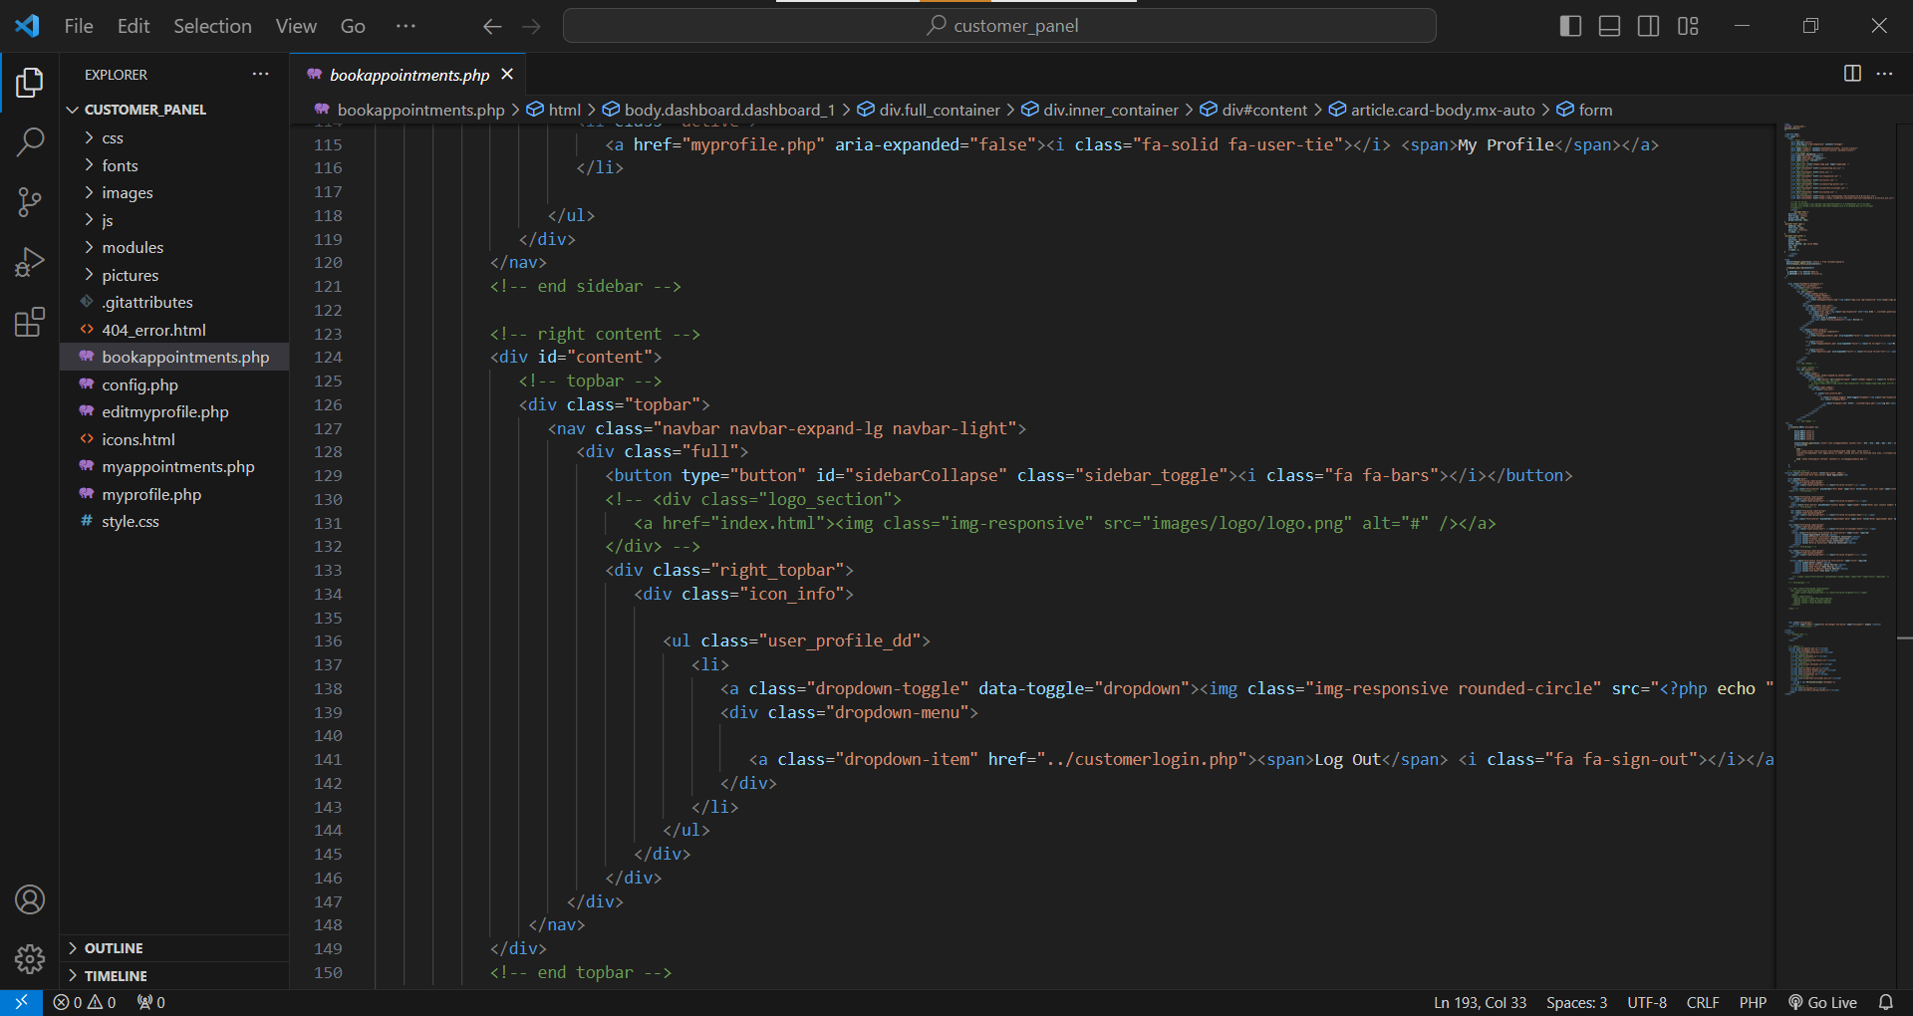

**Developer Guide (Lawyer Panel)**

All Appointments

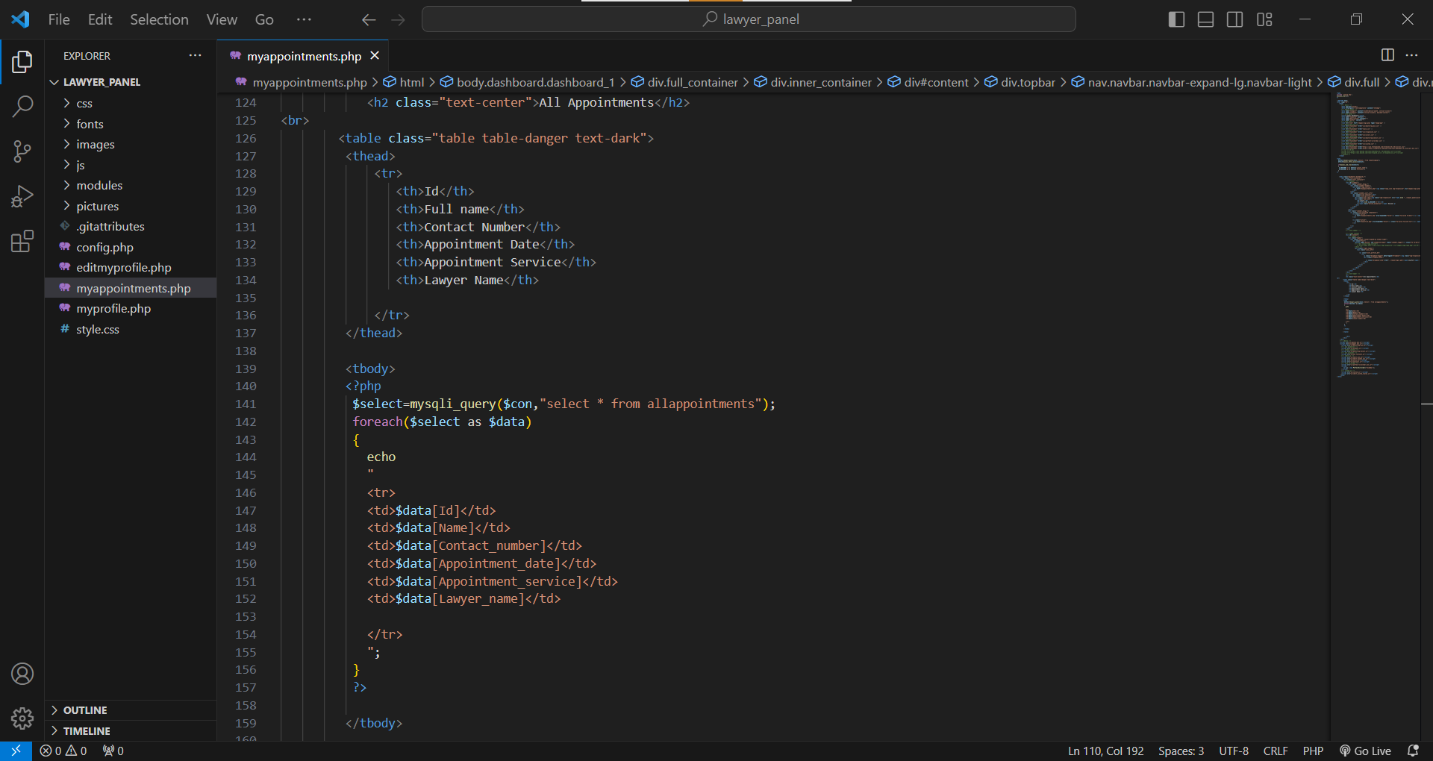Profile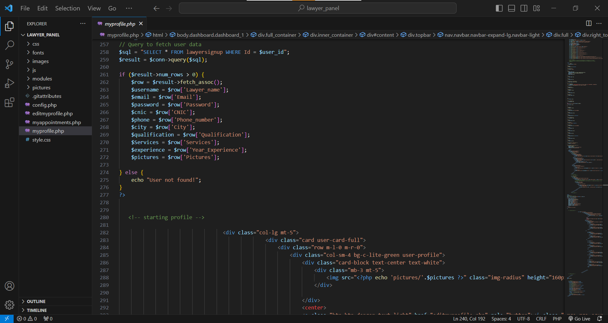

Update Profile

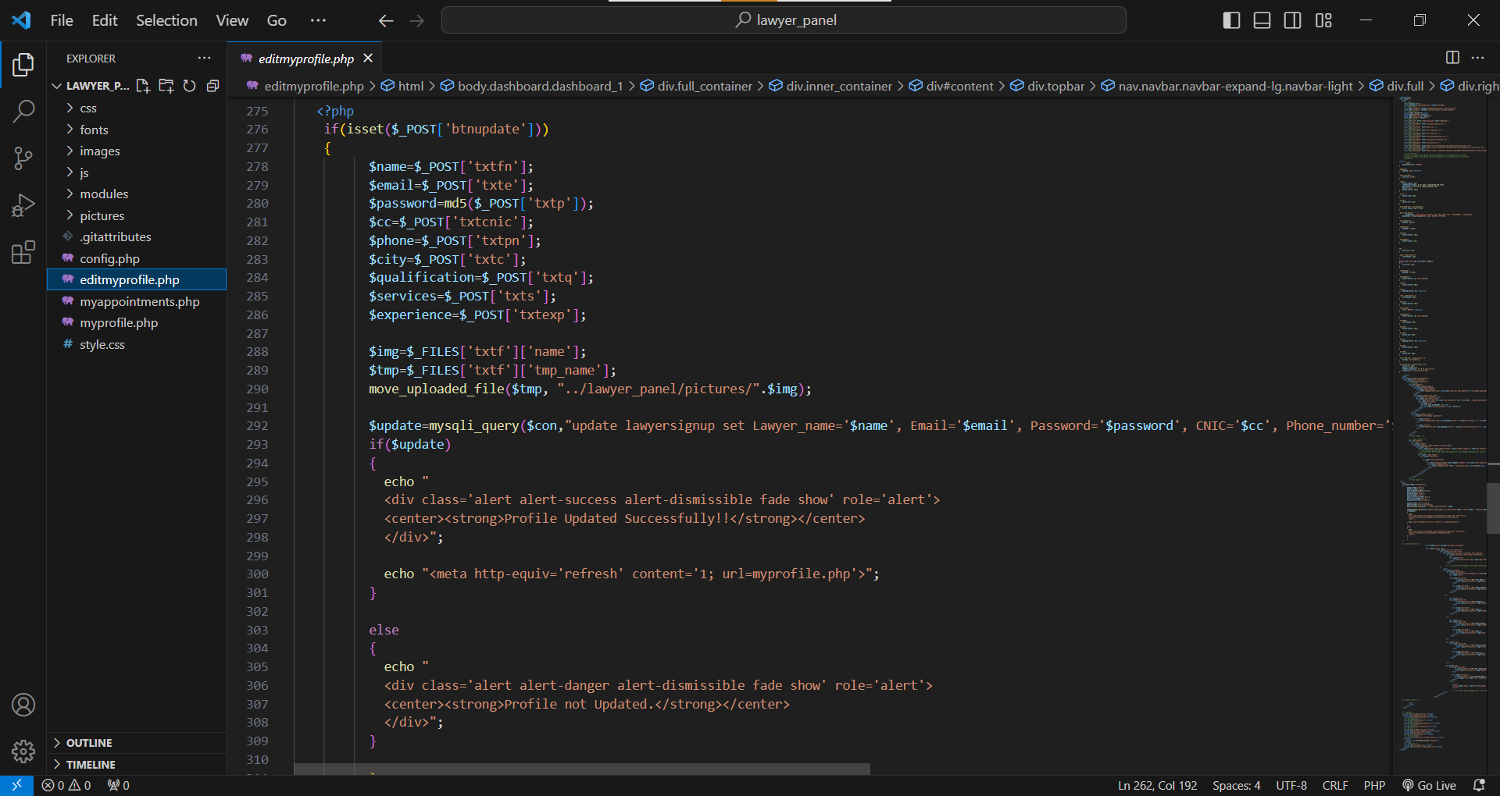

Logout

